Document protector with watermark maker
INDEX
1. Introduction
2. System Analysis
a. Existing System
b. proposed System
3. Feasibility Report
a. Technical Feasibility
b. Operational Feasibility
c. Economical Feasibility
4. System Requirement Specification Document
a. Overview
b. Modules Description
c. Process Flow
d. SDLC Methodology
e. Software Requirements
f. Hardware Requirements
5. System Design
a. E-R diagram
b. UML
c. Data Dictionary
d. Data Flow Diagrams
6. Technology Description
7. Coding
8. Testing & Debugging Techniques
9. Output Screens
11. Future Enhancements
12. Conclusion
INTRODUCTION

Main aim of the project is to provide copyright protection to images over the web. Generally our web site is probably the product of hundreds or thousands of hours of work and an investment of thousands of dollars. All of our original content could easily be copied and displayed to overcome this type of problem copyright protection is needed.

Watermark is a message which is embedded into digital content
(images or text) that can be detected or extracted later. Such messages mostly carry copyright information of the content. Watermarking has been revealed to be an efficient technique to cope with the problem of intellectual property rights (IPR) protection of multimedia data. This technology embeds into the data an unperceivable digital code, namely the watermark, carrying information about the copyright status of the work to be protected.

We mainly concentrate on transmission of images safely through watermarking. Where the authorized user only can obtain the images without distortion.On the request of user we take the image and watermark image.we send it to the user where watermark can be retrieved and image can be viewed.

To our best Knowledge,upto now there is no research that addresses the issue of web application watermarking.in this paper we propose a new watermarking scheme for web applications.

1.1 Current Scenario:
The rapid evolution of the Internet technology makes the transmission of digital multimedia contents easier now a days than before. Copyrighted digital media such as Images, music, etc, can be copied or distributed quickly and easily on the Internet. Media content owners are very concerned about the potential loss of revenue resulting from digital media piracy. Therefore, digital watermarking techniques have been proposed for copyright protection or ownership identification of digital media.
Watermark is a message which is embedded into digital content (audio, video, images or text) that can be detected or extracted later. Such messages mostly carry copyright information of the content. Watermarking has been revealed to be an efficient technique to cope with the problem of intellectual property rights (IPR) protection of multimedia data. This technology embeds into the data an unperceivable digital code, namely the watermark, carrying information about the copyright status of the work to be protected.there are two types of watermarking based on visibility. Those are visible watermarking and non-visible watermarking

Both visible and invisible watermarking involves "stamping" your image in such a way that it can be identified as your image. Using a combination of the two is a very good way to make sure everyone realizes that you own the rights to your images.

1.2 Proposed Solution

We mainly concentrate on transmission of images safely through watermarking. Where the authorized user only can obtain the images without distortion.On the request of user we take the image and watermark image.we send it to the user where watermark can be checked and image can be viewed.

Overview:
Hold a Rs100 note up or your offer letter up to light. What you will see is a picture of Mahatma Gandhi or company’s logo respectively. This is what is known as a watermark mainly used to prove the ownership (in case of offer letter, watermark prove that the document is officialdocument of company meant for official work) or authenticity (in case of Rs 100, watermark ruleout the forgery and authenticate the piece of paper of its worth).The watermark on the Rs100 (Figure2.1), just like most paper watermarks today, has twoproperties. First, the watermark is hidden from view during normal use, only becoming visible asa result of a special viewing process (in this case, holding the bill up to the light). Second, thewatermark carries information about the object in which it is hidden (in this case, the watermark indicates the authenticity of the bill).Fig 2.1 Image showing an INR 100 note having watermark at its left side which is considerably visiblewhen note hold under light.

Watermark
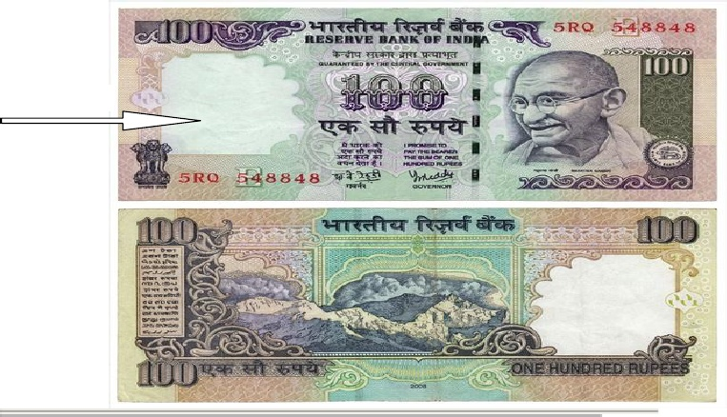

Requirements for WaterMarking Algarithems:
In addition to paper, watermarking can be applied to other physical objects and to electronicsignals. Fabrics, garment labels, and product packaging are examples of physical objectsthat can be watermarked using special invisible dyes and inks Electronic representations of music, photographs, and video are common types of signals that can be watermarked.Thus, watermarking is defined as,

“the practice of imperceptibly altering a Work to embed amessage about that Work.”

As is clear from the figure, digital watermarking model consist of an embedder and a detector.

The embedder takes two inputs. One is the payload we want to embed (the watermark ),and the other is the cover work in which we want to embed the payload. The output of theembedder is typically transmitted or recorded. Later, that Work (or some other Work thathas not been through the embedder) is presented as an input to the detector. Most detectors tryto determine whether a payload is present, and if so, output the message encoded by it.The watermarking model is analogous to a communication model in which sender encode amessage before transmitting it over communication channel and on receiving, receiver decodethe encoded message.
Requirements for watermarking algorithms:
A watermarking algorithm should be consistent over following properties and parameters:

Transparency: The most fundamental requirement for any Watermarking method shall besuch that it is transparent to the end user. The watermarked content should be consumableat the intended user device without giving annoyance to the user. Watermark only showsup at the watermark-detector device.

Security: Watermark information shall only be accessible to the authorized parties. Onlyauthorized parties shall be able to alter the Watermark content. Encryption can be used toprevent unauthorized access of the watermarked data Ease of embedding and retrieval: Ideally, Watermarking on digital media should be possible to be performed “on the fly”. The computation need for the selected algorithm
Should be minimum.

Robustness: Watermarking must be robust enough to withstand all kinds for signal processing operations, “attacks” or unauthorized access. Any attempt, whether intentionalor not, that has a potential to alter the data content is considered as an attack. Robustnessagainst attack is a key requirement for Watermarking and the success of this technologyfor copyright protection depends on this.Effect on

Bandwidth: Watermarking should be done in such a way that it doesn’t increase the bandwidth required for transmission. If Watermarking becomes a burden for theavailable bandwidth, the method will be rejected.

Interoperability: Digitally watermarked content shall still be interoperable so that it canbe seamlessly accessed through heterogeneous networks and can be played on variousplayout devices that may be watermark aware or unaware.

Importance of Digital Watermarking
The sudden increase in watermarking interest is most likely due to the increase in concernover copyright protection of content. The Internet had become user friendly with the introduction of Marc Andreessen’s Mosaic
web browser in November 1993, and it quickly became clear thatpeople wanted to download pictures, music, and videos. The Internet is an excellent distributionsystem for digital media because it is inexpensive, eliminates warehousing and stock, anddelivery is almost instantaneous. However, content owners (especially large Hollywood studiosand music labels) also see a high risk of piracy. This risk of piracy is exacerbated by theproliferation of high-capacity digital recording devices. When the only way the averagecustomer could record a song or a movie was on analog tape, pirated copies wereusually of a lower quality than the originals, and the quality of second-generation piratedcopies (i.e., copies of a copy) was generally very poor. However, with digital recording devices,songs and movies can be recorded with little, if any, degradation in quality. Using theserecording devices and using the Internet for distribution, would-be pirates can easilyrecord and distribute copyright-protected material without appropriate compensation beingpaid to the actual copyright owners. Thus, content owners are eagerly seeking technologies thatpromise to protect their rights. The first technology content owners turn to is cryptography.Cryptography is probably the most common method of protecting digital content. It is certainlyone of the best developed as a science. The content is encrypted prior to delivery, and adecryption key is provided only to those who have purchased legitimate copies of thecontent. The encrypted file can then be made available via the Internet, but would be useless to apirate without an appropriate key. Unfortunately, encryption cannot help the seller monitor howa legitimate customer handles the content after decryption. A pirate can actually purchase theproduct, use the decryption key to obtain an unprotected copy of the content, and thenproceed to distribute illegal copies. In other words, cryptography can protect content intransit, but once decrypted, the content has no further protection. Thus, there is a strong needfor an alternative or complement to cryptography: a technology that can protect content evenafter it is decrypted. Watermarking has the potential to fulfill this need because it placesinformation within the content where it is never removed during normal usage. Decryption, reencryption, compression, digital-to-analog conversion, and file format changes a watermark can be designed to survive all of these processes. Watermarking has been considered for manycopy prevention and copyright protection applications. In copy prevention, the watermark maybe used to inform software or hardware devices that copying should be restricted. Incopyright protection applications, the watermark may be used to identify the copyrightholder and ensure proper payment of royalties.Although copy prevention and copyright protection have been major driving forcesbehind research in the watermarking field, there is a number of other applications for whichwatermarking has been used or suggested. These include broadcast monitoring, transactiontracking, authentication (with direct analogy to our Rs100 example), copy control, and devicecontrol.

Applications of Digital Watermarking
Digital Watermarks are potentially useful in many applications, including:
Ownership assertion:
Watermarks can be used for ownership assertion. To assertownership of an image, Alice can generate a watermarking signal using a secret privatekey, and then embed it into the original image. She can then make the watermarkedimage publicly available. Later, when Bob contends the ownership of an image derivedfrom this public image, Alice can produce the unmarked original image and alsodemonstrate the presence of her watermark in Bob’s image. Since Alice’s original imageis unavailable to Bob, he cannot do the same. For such a scheme to work, the watermark has to survive image processing operations aimed at malicious removal. In addition, thewatermark should be inserted in such a manner that it cannot be forged as Alice wouldnot want to be held accountable for an image that she does not own.

Fingerprinting: In applications where multimedia content is electronically distributedover a network, the content owner would like to discourage unauthorized duplication anddistribution by embedding a distinct watermark (or a fingerprint) in each copy of the data.If, at a later point in time, unauthorized copies of the data are found, then the origin of thecopy can be determined by retrieving the fingerprint. In this application the watermark needs to be invisible and must also be invulnerable to deliberate attempts to forge,remove or invalidate. Furthermore, and unlike the ownership assertion application, thewatermark should be resistant to collusion. That is, a group of k users with the sameimage but containing different fingerprints should not be able to collude and invalidateany fingerprint or create a copy without any fingerprint.

Copy prevention or control. Watermarks can also be used for copy prevention andcontrol. For example, in a closed system where the multimedia content needs specialhardware for copying and/or viewing, a digital watermark can be inserted indicating thenumber of copies that are permitted. Every time a copy is made the watermark can bemodified by the hardware and after a point the hardware would not create further copies
of the data. An example of such a system is the Digital Versatile Disc (DVD). In fact, acopy protection mechanism that includes digital watermarking at its core is currentlybeing considered for standardization and second generation DVD players may wellinclude the ability to read watermarks and act based on their presence or absence.Another example is in digital cinema, where information can be embedded as awatermark in every frame or a sequence of frames to help investigators locate the sceneof the piracy more quickly and point out weaknesses in security in the movie’sdistribution. The information could include data such as the name of the theater and thedate and time of the screening. The technology would be most useful in fighting a formof piracy that’s surprisingly common, i.e., when someone uses a camcorder to record themovie as it’s shown in a theater, then duplicates it onto optical disks or VHS tapes for distribution.
Fraud and tamper detection.ID card security. Information in a passport or ID (e.g., passport number, person’s name,etc.)can also be included in the person’s photo that appears on the ID. By extracting theembedded information and comparing it to the written text, the ID card can be verified.The inclusion of the watermark provides an additional level of security in thisapplication. For example, if the ID card is stolen and the picture is replaced by a forgedcopy, the failure in extracting the watermark will invalidate the ID card. The aboverepresent a few example applications where digital watermarks could potentially be of use. In addition there are many other applications in rights management and protectionlike tracking use of content, binding content to specific players, automatic billing forviewing content, broadcast monitoring etc. From the variety of potential applicationsexemplified above it is clear that a digital watermarking technique needs to satisfy anumber of requirements. Since the specific requirements vary with the application,watermarking techniques need to be designed within the context of the entire system inwhich they are to be employed. Each application imposes different requirements andwould require different types of invisible or visible watermarking schemes or acombination thereof. In the remaining sections of this chapter we describe some generalprinciples and techniques for invisible watermarking. Our aim is to give the reader abetter understanding of the basic principles, inherent trade-offs, strengths, and weakness,of digital watermarking. We will focus on image watermarking in our discussions andexamples. However as we mentioned earlier, the concepts involved are general in natureand can be applied to other forms of content such as video and audio.

FEASIBILITY REPORT:
TECHNICAL FEASIBILITY:
Evaluating the technical feasibility is the trickiest part of a feasibility study. This is because, at this point in time, not too many detailed design of the system, making it difficult to access issues like performance, costs on (on account of the kind of technology to be deployed) etc. A number of issues have to be considered while doing a technical
analysis.
- Understand the different technologies involved in the proposed system:
Before commencing the project, we have to be very clear about what are the technologies that are to be required for the development of the new system.
- Find out whether the organization currently possesses the required technologies:
  - Is the required technology available with the organization?
  - If so is the capacity sufficient?
For instance –
“Will the current printer be able to handle the new reports and forms required for the new system?”

OPERATIONAL FEASIBILITY:
Proposed projects are beneficial only if they can be turned into information systems that will meet the organizations operating requirements. Simply stated, this test of feasibility asks if the system will work when it is developed and installed. Are there major barriers to Implementation? Here are questions that will help test the operational feasibility of a project:
- Is there sufficient support for the project from management from users? If the current system is well liked and used to the extent that persons will not be able to see reasons for change, there may be resistance.
- Are the current business methods acceptable to the user? If they are not, Users may welcome a change that will bring about a more operational and useful systems.
- Have the user been involved in the planning and development of the project?
- Early involvement reduces the chances of resistance to the system and in
- General and increases the likelihood of successful project.
Since the proposed system was to help reduce the hardships encountered. In the existing manual system, the new system was considered to be operational feasible.
ECONOMIC FEASIBILITY:
Economic feasibility attempts 2 weigh the costs of developing and implementing a new system, against the benefits that would accrue from having the new system in place. This feasibility study gives the top management the economic justification for the new system.
A simple economic analysis which gives the actual comparison of costs and benefits are much more meaningful in this case. In addition, this proves to be a useful point of reference to compare actual costs as the project progresses. There could be various types of intangible benefits on account of automation. These could include increased customer satisfaction, improvement in product quality better decision making timeliness of information, expediting activities, improved accuracy of operations, better documentation and record keeping, faster retrieval of information, better employee morale.

SYSTEM REQUIREMENT SPECIFICATION

NUMBER OF MODULES:

Modules:

- Admin Module
- Users Module
- Image Water Marking Module
- Security Authentication

Admin Module:
1. View registered users.
2. Delete registered usrs.
3. View Requested users.
4. Update status (or) Accept Requested users
5. View Inbox mails
6. View Inbox Water Mark Images.
7. View Outbox mails
8. View outboxes water mark images.

Users Modules
1. Delete.read and download water mark images with private key.
2. Image Water markng with text.
3. Image water marking with another image.
4. Watermarking with image type file to any type of other files (video, audio, txt, image, pdf etc).
5. Send these watermark attachments to registered users.
6. File encryption and decryption with user’s private keys and send mails to these files to registered users.
7. Composing mails.
8. Chating Assistence with remaing users.

Image Water Marking:
Rich user interface developed in order to select the image and select the watermarking settings based on the application. It also helps to view the extracted watermark from that electronic commerce application.
Text Watermarking:
Many paper documents (e.g., contracts, wills, etc.) are more valuable than multimedia like sound clips and images. Digital libraries and archives distribute copyrighted articles, journals, and books in electronic form. Watermarking of text documents provides a means of tracing documents that have been illegally copied, distributed, altered, or forged. Raw text, such as an ASCII text file or computer source code, cannot be watermarked because there is no “perceptual headroom” in which to embed hiddeninformation. However, final versions of documents are typically formatted (e.g., PostScript, PDF, RTF), and it is possible to hide a watermark in the layout information (e.g., word and line spacings) and formatting (e.g., serifs). Although optical character recognition (OCR) can theoretically remove any layout information, OCR is expensive, imperfect, and often requires manual supervision.
Brassil et al. [20–22] have investigated text watermarking and proposed varietyof methods for embedding hidden messages in PostScript documents. The work ofBrassil et al. currently does not use SS embedding, but it could be added to thesystem to strengthen robustness and security.
In [20–22], the message is embedded by altering different parts of the document.Line shifting moves entire lines of text up or down by a small amount, typically1/150 or 1/300 inch (0.170 or 0.085 mm). Similarly, word shifting may horizontallyshift individual words or blocks of words; words at the ends of a line are not shiftedto preserve justification. Figure 4 provides an example of word shifting. Finally, feature coding modifies small parts of characters themselves Recovery of the message from a printed or photocopied document requires a numberof post-processing steps (scanning, skew correction, and noise removal). Afterpost-processing, the message receiver automatically measures line shifts, wordshifts, and/or feature alterations to detect the message.In experiments, these methods have shown promise. Line shifts could be correctlydetected even after photocopying ten times. Word shifts on a single page werecorrectly detected 75 percent of the time, after photocopying four times or afterfax transmission. With simple ECC, 26–30 of 30 embedded message bits per pagecould be decoded, depending upon the amount of degradation (e.g., photocopyingmultiple times).

Image Watermarking:
Digital images can be produced from many sources, such as everyday photographs, satellite pictures, medical scans, or computer graphics. Watermarks for natural images typically modify pixel intensities or transform coefficients, although it is conceivable that a watermark could alter other features such as edges or textures. An image may be viewed for an extended period of time, and it may also be subjectto a great deal of manipulation, such as filtering, cropping, geometric transformations, compression, and compositing with other images, and hostile attacks. Thus, imperceptibility, robustness, and security are usually the most important propertiesof image watermarks; speed and complexity are often secondary. Also, since manyimages are compressed (e.g., JPEG or GIF), watermarking algorithms that operatein the transform or wavelet domain may be useful. One potential difficulty in image watermarking is the finite bandwidth available.As the image size decreases, the permissible message length decreases unless E isincreased (weakening imperceptibility) or N is decreased (weakening robustness).The example watermarking system in Figures 2 and 3 has been directly developedinto a system that embeds a spatial-domain DSSS image watermark. Figure5 compares an original, unmarked image with its watermarked counterpart. The two images are indistinguishable perceptually. The original image is a 256 _ 2568-bit grayscale image. The watermark was embedded a chip rate of N = 4096and per-pixel amplitude qE=N = 2. Hence, the total power per message bit wasE = 16384.
The marked image was then subjected to a number of different attacks. Examplemarked images after attack appear in Figure 6. The watermark message remainedrecoverable after addition of Gaussian noise with variance 400, a sinusoidal patternwith amplitude 30, and a constant offset of 30. The watermark also survived JPEGcompression with a quality factor of 20 percent (compressed to 4959 bytes, or 13:1Compression).A free software program called StirMark [19,23] is available for testing watermarkrobustness. StirMark simulates printing and rescanning of an image, and its producersclaim that it can defeat several commercial watermarking systems. The SSwatermark, however, survived StirMark and the embedded message was recoveredwithout any bit errors.
Insertion of Watermark Image into Cover Work:

Algorithm Explanation
The aim of the program is to replace the LSB of the base image with the MSB of the watermark. First, the program asks the user for the images to be read. The user will then enter the name of the images, both the base and the watermark, with their extension. Both these images will be read. . The program will then change the image size to double. This is done so as inform to provide double data-type space for the images. The reason for doing so, is to provide decimal storage for the subsequent additional operations which will be performed on the base and watermark image
The next step is to assign the number of most significant bits of the watermark which will be used to overwrite on the least significant bit spaces of the base signal. Once the user provides this, the watermark signal bits are shifted to the right by the specified bits. 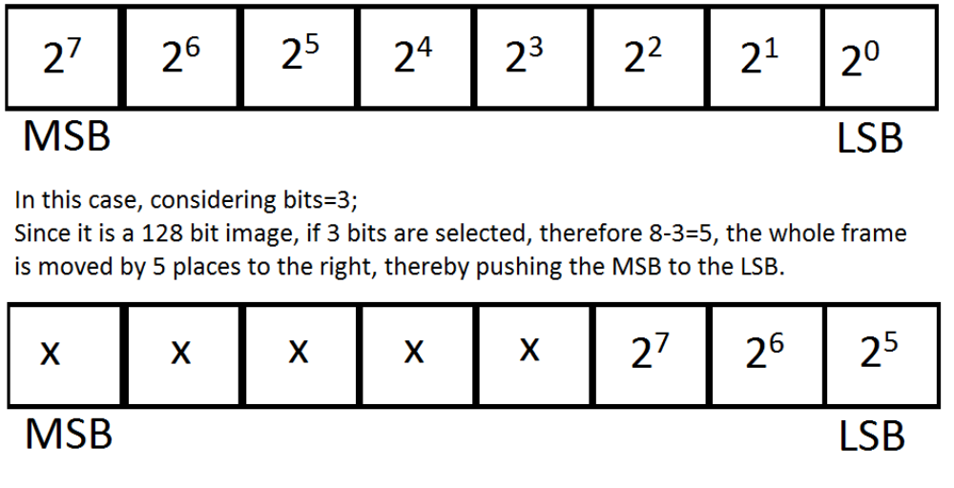 An exact number of these bits will be made zero in the LSB of the base image. The reason for making them zero, is to provide space for the MSB of watermark to be stored. 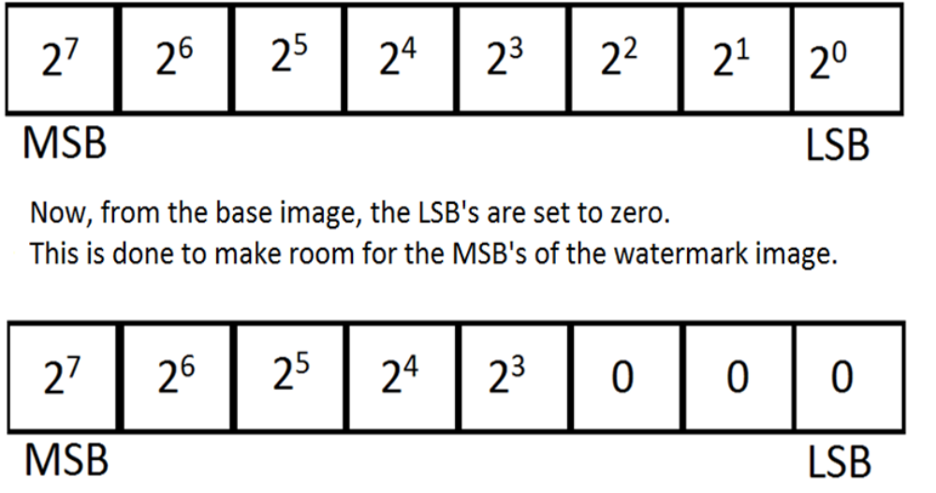 The bits of both the images, i.e. watermark image which now has its MSB shifted to its LSB, and the base image, which has its LSBs are set zero, are added. The added image gives us the watermarked signal. o The final image obtained. 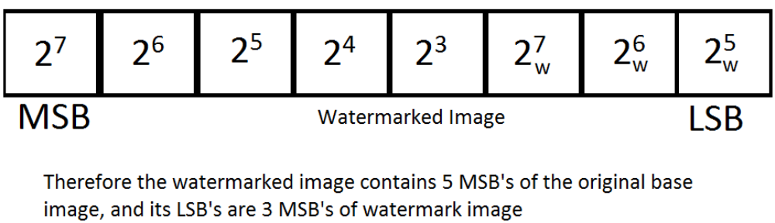 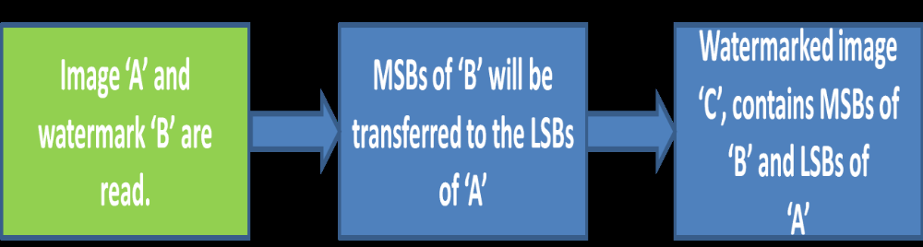

Results:



Watermarked Image , using bits=1. Since it is an invisible watermarking scheme, only the base image is visible.

RSA:

The RSA algorithm was publicly described in 1977 by Ron Rivest, Adi Shamir, and Leonard Adleman
The RSA algorithm involves three steps:
key generation, encryption and decryption.

Key generation
RSA involves a public key and a private key.
The public key can be known to everyone and is used for encrypting messages.
Messages encrypted with the public key can only be decrypted using the private key.
The keys for the RSA algorithm are generated the following way:
- Choose two distinct prime numbers p and q.
  - For security purposes, the integers p and q should be chosen at random, and should be of similar bit-length.
- Compute n = pq.
  - n is used as the modulus for both the public and private keys. Its length, usually expressed in bits, is the key length.
- Compute φ(n) = (p – 1)(q – 1), where φ is Euler's totient function.
- Choose an integer e such that 1 < e < φ(n) and greatest common divisor gcd(e, φ(n)) = 1; i.e., e and φ(n) are coprime.
  - e is released as the public key exponent.
  - e having a short bit-length and small Hamming weight results in more efficient encryption – most commonly 2¹⁶ + 1 = 65,537. However, much smaller values of e (such as 3) have been shown to be less secure in some settings.^{[4]}
- Determine d as d ≡ e⁻¹ (mod φ(n)), i.e., d is the multiplicative inverse of e (modulo φ(n)).
- This is more clearly stated as solve for d given de ≡ 1 (mod φ(n))
- This is often computed using the extended Euclidean algorithm.
- d is kept as the private key exponent.
By construction, d⋅e ≡ 1 (mod φ(n)). The public key consists of the modulus n and the public (or encryption) exponent e. The private key consists of the modulus n and the private (or decryption) exponent d, which must be kept secret. p, q, and φ(n) must also be kept secret because they can be used to calculate d.
- An alternative, used by PKCS#1, is to choose d matching de ≡ 1 (mod λ) with λ = lcm(p − 1, q − 1), where lcm is the least common multiple. Using λ instead of φ(n) allows more choices for d. λ can also be defined using the Carmichael function, λ(n).
- The ANSI X9.31 standard prescribes, IEEE 1363 describes, and PKCS#1 allows, that p and q match additional requirements: being strong primes, and being different enough that Fermat factorization fails.

Encryption
Alice transmits her public key (n, e) to Bob and keeps the private key secret. Bob then wishes to send message M to Alice.
He first turns M into an integer m, such that 0 ≤ m < n by using an agreed-upon reversible protocol known as a padding scheme. He then computes the ciphertext c corresponding to
This can be done quickly using the method of exponentiation by squaring. Bob then transmits c to Alice.

Decryption
Alice can recover m from c by using her private key exponent d via computing
Given m, she can recover the original message M by reversing the padding scheme.
(In practice, there are more efficient methods of calculating c^{d} using the precomputed values below.)

A working example
Here is an example of RSA encryption and decryption. The parameters used here are artificially small, but one can also use OpenSSL to generate and examine a real keypair.
- Choose two distinct prime numbers, such as
and .
- Compute n = pq giving
.
- Compute the totient of the product as φ(n) = (p − 1)(q − 1) giving
.
- Choose any number 1 < e < 3120 that is coprime to 3120. Choosing a prime number for e leaves us only to check that e is not a divisor of 3120.
Let .
- Compute d, the modular multiplicative inverse of e (mod φ(n)) yielding
.
The public key is (n = 3233, e = 17). For a padded plaintext message m, the encryption function is m¹⁷ (mod 3233).
The private key is (n = 3233, d = 2753). For an encrypted ciphertext c, the decryption function is c²⁷⁵³ (mod 3233).
For instance, in order to encrypt m = 65, we calculate
To decrypt c = 2790, we calculate
.

Both of these calculations can be computed efficiently using the square-and-multiply algorithm for modular exponentiation. In real life situations the primes selected would be much larger; in our example it would be relatively trivial to factor n, 3233, obtained from the freely available public key back to the primes p and q. Given e, also from the public key, we could then compute d and so acquire the private key.
Practical implementations use the Chinese remainder theorem to speed up the calculation using modulus of factors (mod pq using mod p and mod q).
The values d_{p}, d_{q} and q_{inv}, which are part of the private key are computed as follows:
- (Hence: )
Here is how d_{p}, d_{q} and q_{inv} are used for efficient decryption. (Encryption is efficient by choice of public exponent e)
- (same as above but computed more efficiently)

Securiy Authentication:
- Registeration
- Login
- View profile
- Update Profies
- Change passwords
- Logout
- RecoverPassword

PROCESS FLOW:
ARCHITECTURE DIAGRAM:

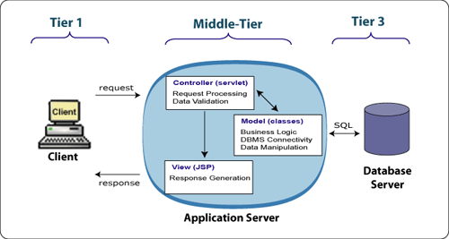

- THE PRESENTATION LAYER
Also called as the client layer comprises of components that are dedicated to presenting the data to the user. For example: Windows/Web Forms and buttons, edit boxes, Text boxes, labels, grids, etc.
- THE BUSINESS RULES LAYER
This layer encapsulates the Business rules or the business logic of the encapsulations. To have a separate layer for business logic is of a great advantage. This is because any changes in Business Rules can be easily handled in this layer. As long as the interface between the layers remains the same, any changes to the functionality/processing logic in this layer can be made without impacting the others. A lot of client-server apps failed to implement successfully as changing the business logic was a painful process

- THE DATA ACCESS LAYER
This layer comprises of components that help in accessing the Database. If used in the right way, this layer provides a level of abstraction for the database structures. Simply put changes made to the database, tables, etc do not affect the rest of the application because of the Data Access layer. The different application layers send the data requests to this layer and receive the response from this layer.
- THE DATABASE LAYER
This layer comprises of the Database Components such as DB Files, Tables, Views, etc. The Actual database could be created using SQL Server, Oracle, Flat files, etc.
In an n-tier application, the entire application can be implemented in such a way that it is independent of the actual Database. For instance, you could change the Database Location with minimal changes to Data Access Layer. The rest of the Application should remain unaffected.

SDLC METHODOLOGIES

This document play a vital role in the development of life cycle (SDLC) as it describes the complete requirement of the system. It means for use by developers and will be the basic during testing phase. Any changes made to the requirements in the future will have to go through formal change approval process.
SPIRAL MODEL was defined by Barry Boehm in his 1988 article, “A spiral Model of Software Development and Enhancement. This model was not the first model to discuss iterative development, but it was the first model to explain why the iteration models.
As originally envisioned, the iterations were typically 6 months to 2 years long. Each phase starts with a design goal and ends with a client reviewing the progress thus far. Analysis and engineering efforts are applied at each phase of the project, with an eye toward the end goal of the project.
The steps for Spiral Model can be generalized as follows:
- The new system requirements are defined in as much details as possible. This usually involves interviewing a number of users representing all the external or internal users and other aspects of the existing system.
- A preliminary design is created for the new system.
- A first prototype of the new system is constructed from the preliminary design. This is usually a scaled-down system, and represents an approximation of the characteristics of the final product.
- A second prototype is evolved by a fourfold procedure:
- Evaluating the first prototype in terms of its strengths, weakness, and risks.
- Defining the requirements of the second prototype.
- Planning an designing the second prototype.
- Constructing and testing the second prototype.
- At the customer option, the entire project can be aborted if the risk is deemed too great. Risk factors might involved development cost overruns, operating-cost miscalculation, or any other factor that could, in the customer’s judgment, result in a less-than-satisfactory final product.
- The existing prototype is evaluated in the same manner as was the previous prototype, and if necessary, another prototype is developed from it according to the fourfold procedure outlined above.
- The preceding steps are iterated until the customer is satisfied that the refined prototype represents the final product desired.
- The final system is constructed, based on the refined prototype.
- The final system is thoroughly evaluated and tested. Routine maintenance is carried on a continuing basis to prevent large scale failures and to minimize down time.
The following diagram shows how a spiral model acts like:

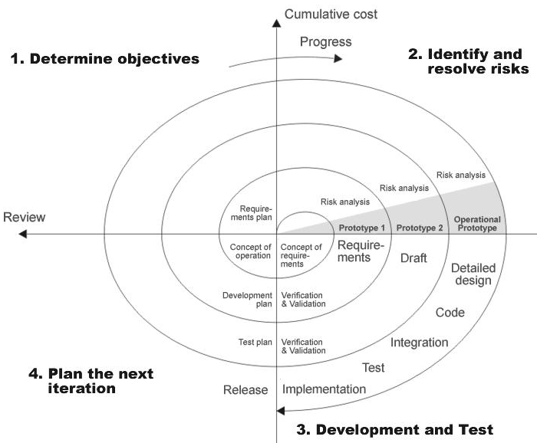

Fig 1.0-Spiral Model

ADVANTAGES

- Estimates(i.e. budget, schedule etc .) become more relistic as work progresses, because important issues discoved earlier.
- It is more able to cope with the changes that are software development generally entails.
- Software engineers can get their hands in and start woring on the core of a project earlier.

SOFTWARE REQUIREMENT AND
HARDWARE REQUIREMENT

SOFTWARE REQUIREMENTS:

Operating System : Windows XP/2003 or Linux
User Interface : HTML, CSS
Client-side Scripting : JavaScript
Programming Language : Java
Web Applications : JDBC, Servlets, JSP
IDE/Workbench : My Eclipse 6.0
Database : Oracle 10g
Server Deployment : Tomcat 6.x

HARDWARE REQUIREMENTS
Processor : core 2 duo
Hard Disk : 160GB
RAM : 1GB or more

SYSTEM DESIGN
E - R Diagrams
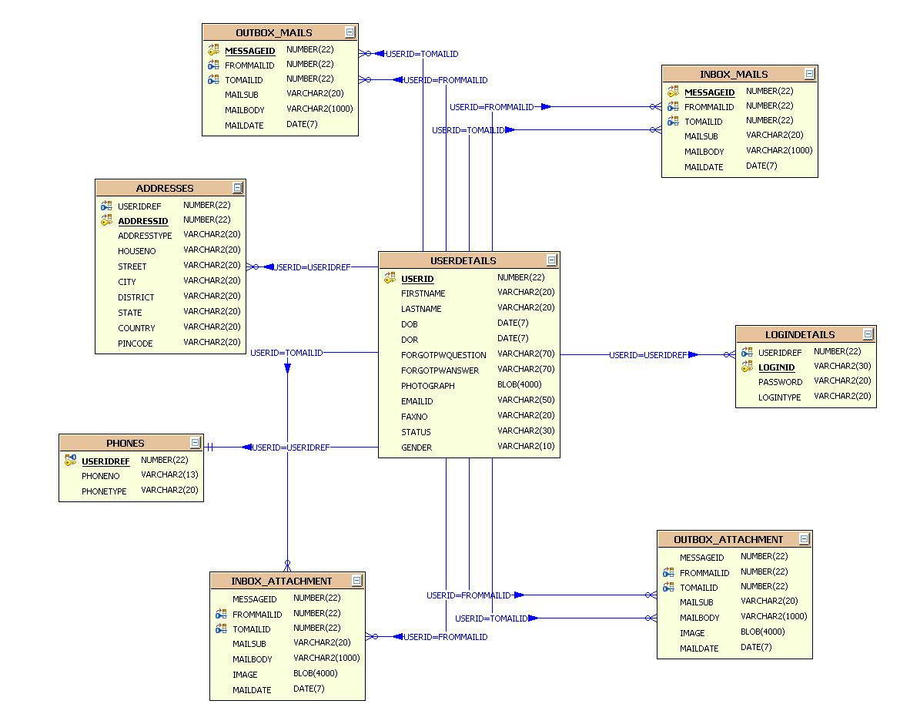

UML DIAGRAMS

UNIFIED MODELING LANGUAGE DIAGRAMS
The unified modeling language allows the software engineer to express an analysis model using the modeling notation that is governed by a set of syntactic semantic and pragmatic rules.

A UML system is represented using five different views that describe the system from distinctly different perspective. Each view is defined by a set of diagram, which is as follows.

USER MODEL VIEW
This view represents the system from the users perspective.
The analysis representation describes a usage scenario from the end-users perspective.

STRUCTURAL MODEL VIEW
In this model the data and functionality are arrived from inside the system.
This model view models the static structures.

BEHAVIORAL MODEL VIEW
It represents the dynamic of behavioral as parts of the system, depicting the interactions of collection between various structural elements described in the user model and structural model view.

IMPLEMENTATION MODEL VIEW
In this the structural and behavioral as parts of the system are represented as they are to be built.
ENVIRONMENTAL MODEL VIEW
In this the structural and behavioral aspects of the environment in which the system is to be implemented are represented.

UML is specifically constructed through two different domains they are:
UML Analysis modeling, which focuses on the user model and structural model views of the system.
UML design modeling, which focuses on the behavioral modeling, implementation modeling and environmental model views.

Use case Diagrams represent the functionality of the system from a user’s point of view. Use cases are used during requirements elicitation and analysis to represent the functionality of the system. Use cases focus on the behavior of the system from external point of view.

Actors are external entities that interact with the system. Examples of actors include users like administrator, bank customer …etc., or another system like central database.

UML Diagrams in Visual Case:
Use Case Diagram:

The Use Case Diagram describes the system functionality
as a set of Use Cases which represent discrete tasks.
Actors interact with the system to complete the tasks.

Class Diagram:

The Class Diagram describes the structure of the software system.
This is the core diagram for object-oriented design.

Sequence Diagram:
The Sequence Diagram describes messages exchanged between
Classes to accomplish tasks.

Collaboration Diagram

The Collaboration Diagram describes interactions between classes and associations.

State Diagram

State Diagrams model the dynamic behaviour of a system by showing the various states that an object can get into and the transitions that occur between the states.
Activity Diagram

The Activity Diagram describes the activities of a class in response to internal events.

Component Diagram

The Component Diagram describes the structure and dependencies among software components.

Deployment Diagram

The Deployment Diagram describes the physical layout of software components.

CLASS DIAGRAM:

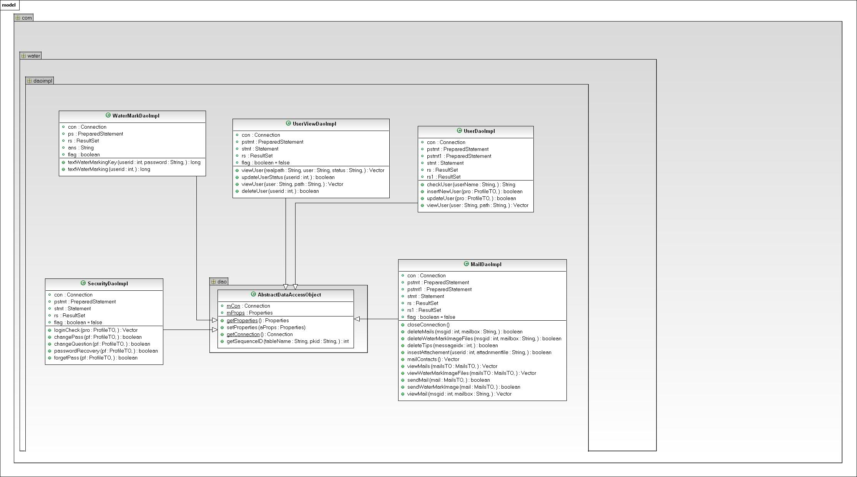

Use Case Diagrams

UML Diagrams
Unified Modeling Language:

The Unified Modeling Language allows the software engineer to express an analysis model using the modeling notation that is governed by a set of syntactic semantic and pragmatic rules.

A UML system is represented using five different views that describe the system from distinctly different perspective. Each view is defined by a set of diagram, which is as follows.
  - User Model View
    - This view represents the system from the users perspective.
    - The analysis representation describes a usage scenario from the end-users perspective.

  - Structural model view
    - In this model the data and functionality are arrived from inside the system.
    - This model view models the static structures.

- Behavioral Model View
It represents the dynamic of behavioral as parts of the system, depicting the interactions of collection between various structural elements described in the user model and structural model view.

- Implementation Model View
In this the structural and behavioral as parts of the system are represented as they are to be built.

- Environmental Model View
In this the structural and behavioral aspects of the environment in which the system is to be implemented are represented.

UML is specifically constructed through two different domains they are:
- UML Analysis modeling, this focuses on the user model and structural model views of the system.
- UML design modeling, which focuses on the behavioral modeling, implementation modeling and environmental model views.

Use case Diagrams represent the functionality of the system from a user’s point of view. Use cases are used during requirements elicitation and analysis to represent the functionality of the system. Use cases focus on the behavior of the system from external point of view.

Actors are external entities that interact with the system. Examples of actors include users like administrator, bank customer …etc., or another system like central database.

- system Use Case Diagram
System
Admin
User
Optimized DWT-based Image Watermarking for Web

- Admin UseCase Diagram :
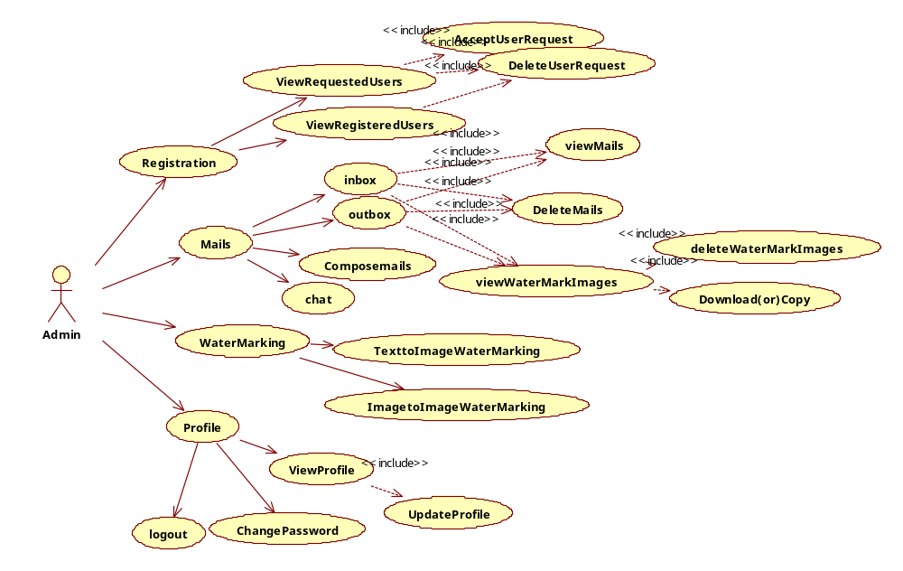
- User UseCase Diagram:
User
Registration
Mails
WaterMarking
Profile
TexttoImageWaterMarking
ViewProfile
ImagetoImageWaterMarking
UpdateProfile
NewRegistration
Composemails
DeleteMails
outbox
chat
inbox
viewMails
deleteWaterMarkImages
viewWaterMarkImages
Download(or)Copy
ChangePassword
logout
<<include>>
<<include>>
<<include>>
<<include>>
<<include>>
<<include>>
<<include>>
<<include>>
<<include>>

Sequence Diagrams

User-Level Sequence Diagrams
Login Sequence Diagram :

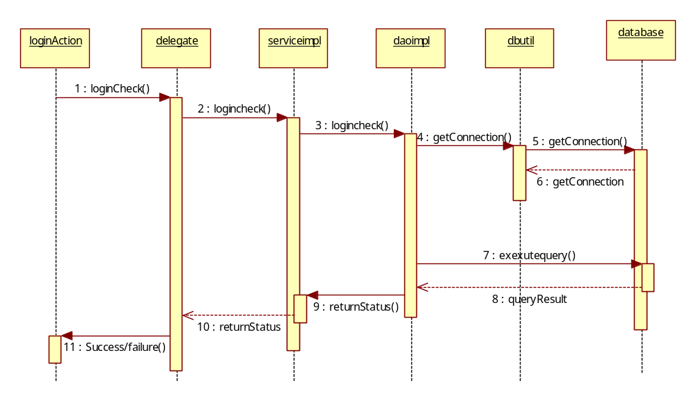
1 : Execute()
ChangePassword Sequence Diagram:

ChangePasswordAction
Securitydelegate
Securityserviceimpl
Securitydaoimpl
dbutil
database
1 :changePass ()
2 : :changePass ()
3 : :changePass ()
4 : getConnection()
5 : getConnection()
6 : getConnection
7 : exexutequery()
8 : queryResult
9 : returnStatus()
10 : returnStatus
11 : Success/failure()
1 : Execute()

ForgetPassword:

ForgetPasswordAction
Securitydelegate
Securityserviceimpl
Securitydaoimpl
dbutil
database
1 :forgetPass ()
2 : :forgetPass ()
3 : : forgetPass ()
4 : getConnection()
5 : getConnection()
6 : getConnection
7 : exexutequery()
8 : queryResult
9 : returnStatus()
10 : returnStatus
11 : Success/failure()
1 : Execute()
Registration Secquence Diagram:
RegistrationAction
Userdelegate
Userserviceimpl
UserDaoImpl
dbutil
database
1 : insertNewUser ()
2 : : insertNewUser ()
3 : : insertNewUser ()
4 : getConnection()
5 : getConnection()
6 : getConnection
7 : exexutequery()
8 : queryResult
9 : boolean
10 : boolean
11 : boolean /failure

1 : Execute()

Update UserProfile Sequence Diagram :

UpdateUserProfileAction
Userdelegate
Userserviceimpl
UserDaoImpl
dbutil
database
1 : updateUser ()
2 : : updateUser ()
3 : : updateUser ()
4 : getConnection()
5 : getConnection()
6 : getConnection
7 : exexutequery()
8 : queryResult
9 : returnStatus()
10 : returnStatus
11 : Success/failure()
1 : Execute()

view UserProfile Sequence Diagram :

ViewProfileAction
Userdelegate
Userserviceimpl
UserDaoImpl
dbutil
database
1 : viewUser ()
2 : : viewUser ()
3 : : viewUser ()
4 : getConnection()
5 : getConnection()
6 : getConnection
7 : exexutequery()
8 : queryResult
9 : returnStatus()
10 : returnStatus
11 : Success/failure()
1 : Execute()

Login Sequence Collabration Diagram :
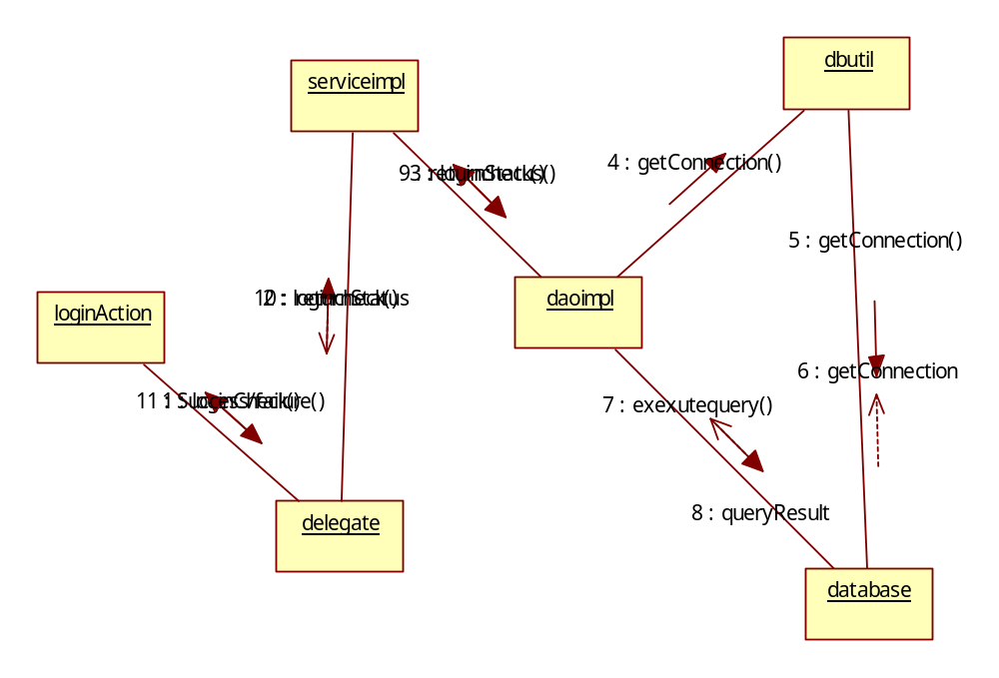

Changepassword SequenceCollbration diagram:
ChangepasswordAction
Securitydelegate
Securityserviceimpl
Securitydaoimpl
dbutil
database
1 : changePass()
2 :changePass()
3 : changePass()
4 : getConnection()
5 : getConnection()
6 : getConnection
7 : exexutequery()
8 : queryResult
9 : returnStatus()
10 : returnStatus
11 : Success/failure()

ForgetpasswordAction
Securitydelegate
Securityserviceimpl
Securitydaoimpl
dbutil
database
1 : forgetPass ()
2 :forgetPass()
3 : forgetPass ()
4 : getConnection()
5 : getConnection()
6 : getConnection
7 : exexutequery()
8 : queryResult
9 : returnStatus()
10 : returnStatus
11 : Success/failure()

Registration Sequence CollbrationDiagram:
RegistrationAction
Userdelegate
Userserviceimpl
Userdaoimpl
dbutil
database
1 : insertNewUser()
2 : insertNewUser()
3 : insertNewUser ()
4 : getConnection()
5 : getConnection()
6 : getConnection
7 : exexutequery()
8 : queryResult
9 : returnStatus()
10 : returnStatus
11 : Success/failure()

Update UserProfile SequenceCollbration Diagram:
UpdateUserProfileAction
Userdelegate
Userserviceimpl
Userdaoimpl
dbutil
database
1 : updateUser ()
2 : updateUser()
3 : updateUser ()
4 : getConnection()
5 : getConnection()
6 : getConnection
7 : exexutequery()
8 : queryResult
9 : returnStatus()
10 : returnStatus
11 : Success/failure()

View UserProfile Sequence Collabration Diagram:

ViewUserProfileAction
Userdelegate
Userserviceimpl
Userdaoimpl
dbutil
database
1 : viewUser ()
2 : viewUser ()
3 : viewUser ()
4 : getConnection()
5 : getConnection()
6 : getConnection
7 : exexutequery()
8 : queryResult
9 : returnStatus()
10 : returnStatus
11 : Success/failure()

ACTIVITY DIAGRAMS:

Admin Activity Diagrms :

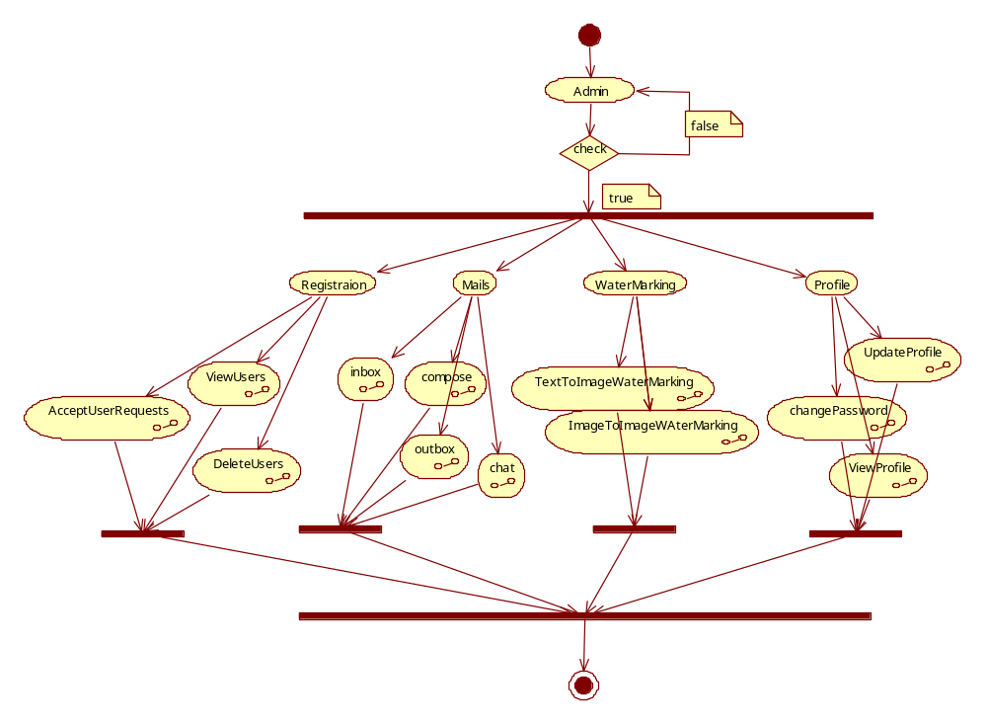

User Activivty Diagram:

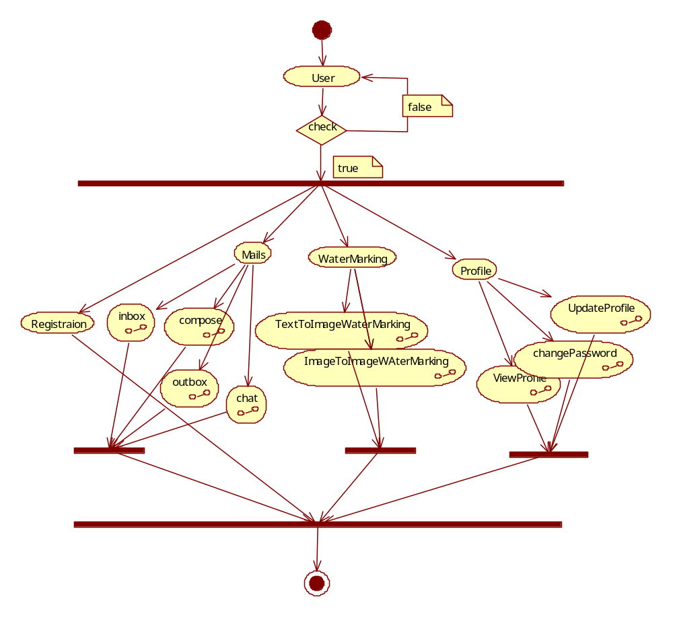

Component Diagram:

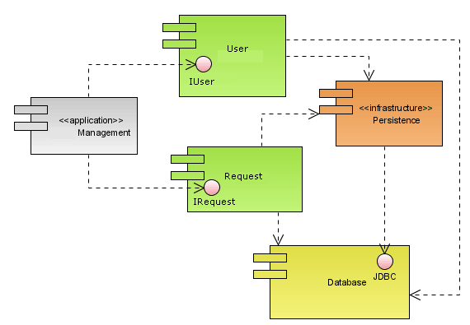

Deployment Diagram:

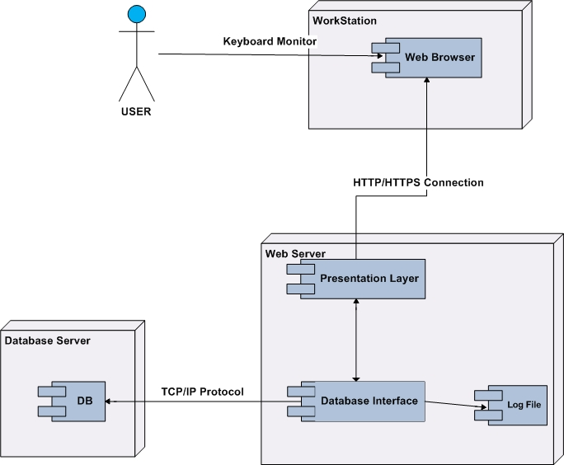

Data Dictionary
ADDRESSES
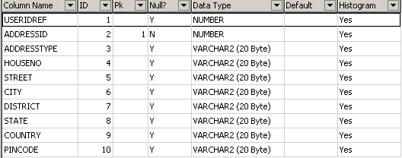

INBOX_ATTACHMENT
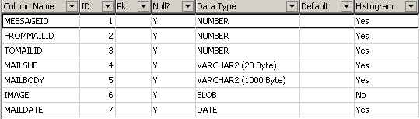

INBOX_MAILS

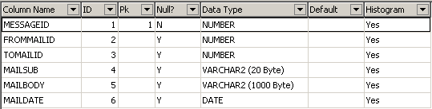

LOGINDETAILS:

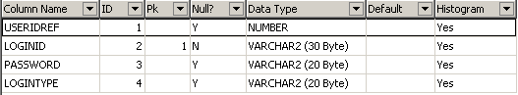

OUTBOX_MAILS

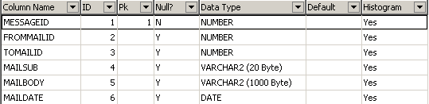

OUTBOX_ATTACHMENT

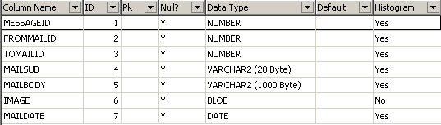

PHONES
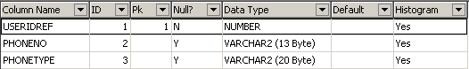

USERDETAILS
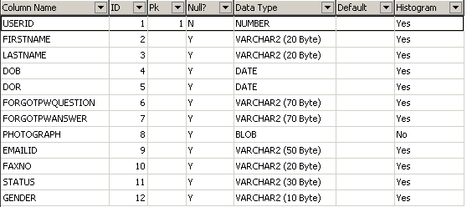

DATA FLOW DIAGRAMS

DATA FLOW DIAGRAMS:
A graphical tool used to describe and analyze the moment of data through a system manual or automated including the process, stores of data, and delays in the system. Data Flow Diagrams are the central tool and the basis from which other components are developed. The transformation of data from input to output, through processes, may be described logically and independently of the physical components associated with the system. The DFD is also know as a data flow graph or a bubble chart.
DFDs are the model of the proposed system. They clearly should show the requirements on which the new system should be built. Later during design activity this is taken as the basis for drawing the system’s structure charts. The Basic Notation used to create a DFD’s are as follows:
1. Dataflow: Data move in a specific direction from an origin to a destination.

2. Process: People, procedures, or devices that use or produce (Transform) Data. The physical component is not identified.

3. Source: External sources or destination of data, which may be People, programs, organizations or other entities.

4. Data Store: Here data are stored or referenced by a process in the System.

DATA FLOW DIAGRAM: 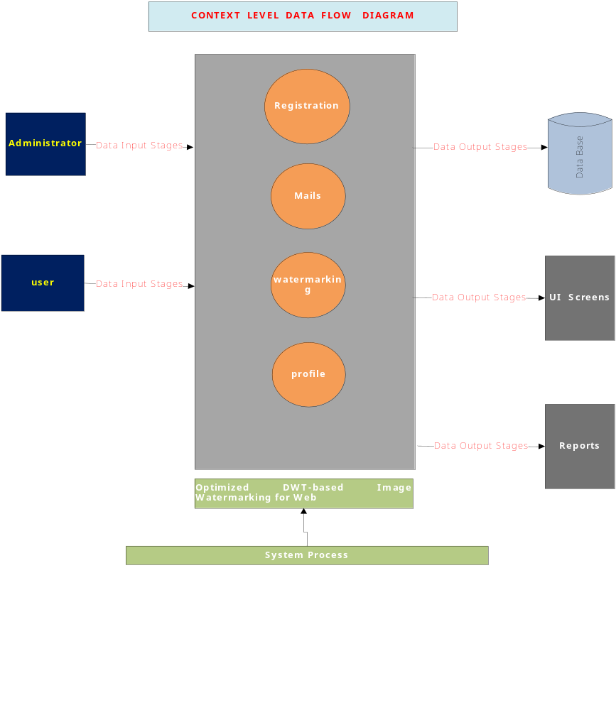

LEVEL-1:

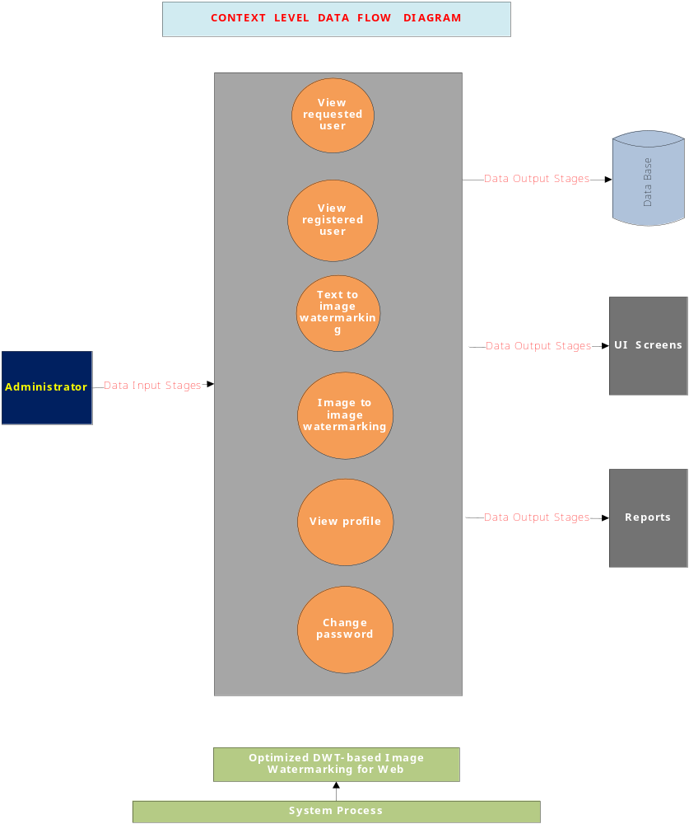

LEVEL-2:
Administrator:

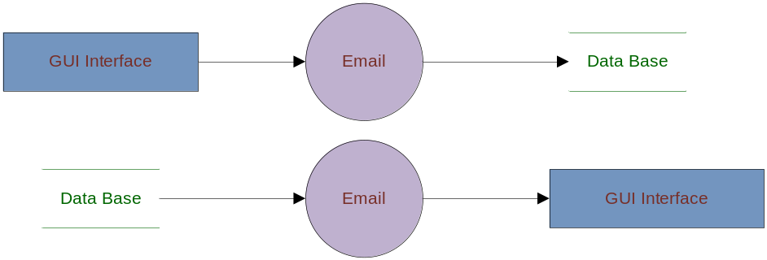

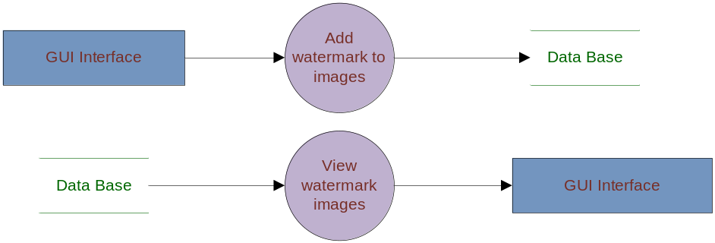

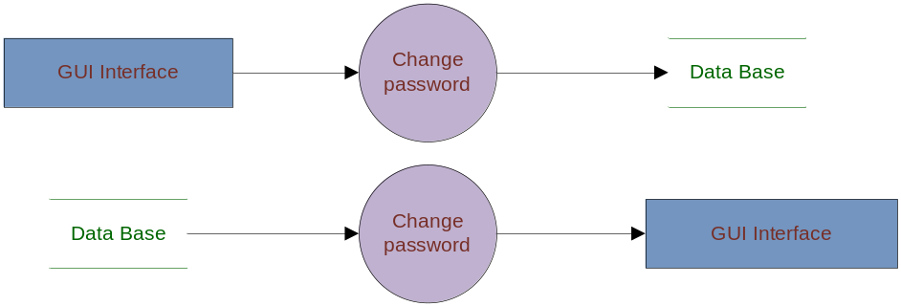

LEVEL-1:
User: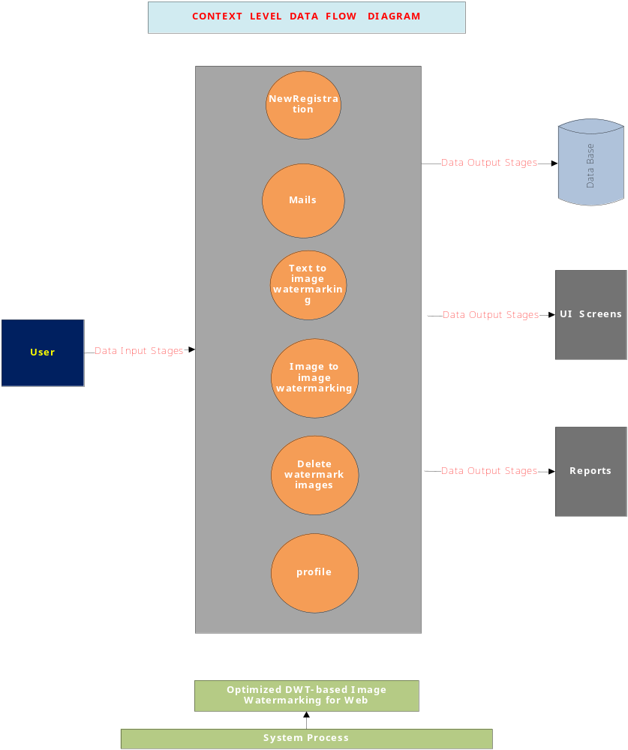
LEVEL-2:

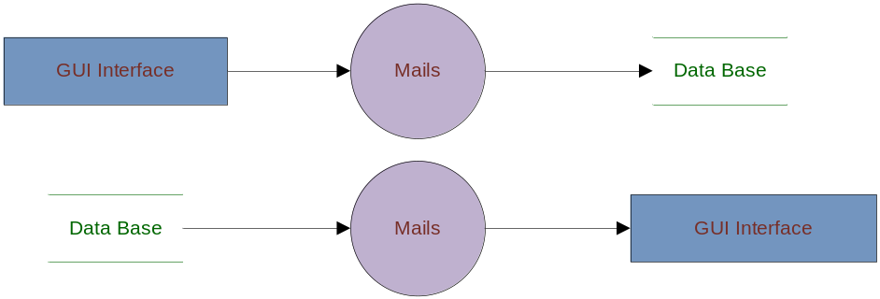

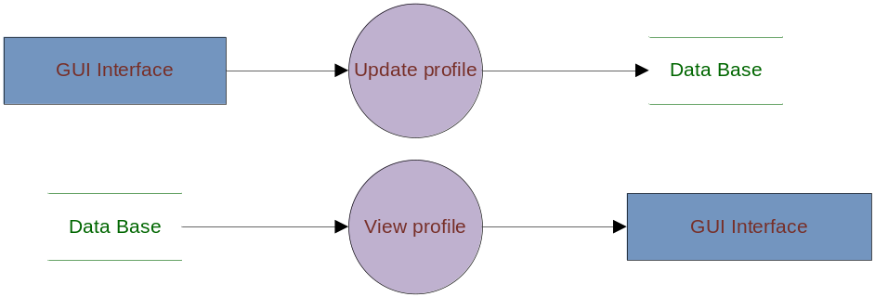

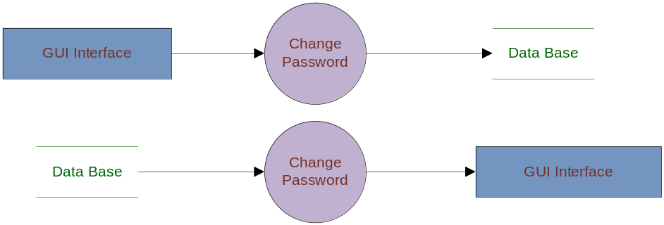

Authentication:

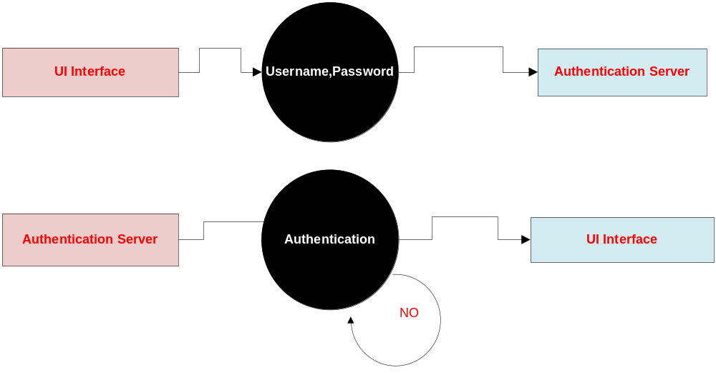

TECHNOLOGY DESCRIPTION

HTML

HTML, an initialism of Hypertext Markup Language, is the predominant markup language for web pages. It provides a means to describe the structure of text-based information in a document — by denoting certain text as headings, paragraphs, lists, and so on — and to supplement that text with interactive forms, embedded images, and other objects. HTML is written in the form of labels (known as tags), surrounded by angle brackets. HTML can also describe, to some degree, the appearance and semantics of a document, and can include embedded scripting language code which can affect the behavior of web browsers and other HTML processors.

HTML is also often used to refer to content of the MIME type text/html or even more broadly as a generic term for HTML whether in its XML-descended form (such as XHTML 1.0 and later) or its form descended directly from SGML

Hyper Text Markup Language
Hypertext Markup Language (HTML), the languages of the World Wide Web (WWW), allows users to produces Web pages that include text, graphics and pointer to other Web pages (Hyperlinks).
HTML is not a programming language but it is an application of ISO Standard 8879, SGML (Standard Generalized Markup Language), but specialized to hypertext and adapted to the Web. The idea behind Hypertext is that instead of reading text in rigid linear structure, we can easily jump from one point to another point. We can navigate through the information based on our interest and preference. A markup language is simply a series of elements, each delimited with special characters that define how text or other items enclosed within the elements should be displayed. Hyperlinks are underlined or emphasized works that load to other documents or some portions of the same document.
HTML can be used to display any type of document on the host computer, which can be geographically at a different location. It is a versatile language and can be used on any platform or desktop.
HTML provides tags (special codes) to make the document look attractive. HTML tags are not case-sensitive. Using graphics, fonts, different sizes, color, etc., can enhance the presentation of the document. Anything that is not a tag is part of the document itself.

Basic HTML Tags:
<! -- --> specifies comments
<A>……….</A> Creates hypertext links
<B>……….</B> Formats text as bold
<BIG>……….</BIG> Formats text in large font.
<BODY>…</BODY> Contains all tags and text in the HTML document
<CENTER>...</CENTER> Creates text
<DD>…</DD> Definition of a term
<DL>...</DL> Creates definition list
<FONT>…</FONT> Formats text with a particular font
<FORM>...</FORM> Encloses a fill-out form
<FRAME>...</FRAME> Defines a particular frame in a set of frames
<H#>…</H#> Creates headings of different levels( 1 – 6 )
<HEAD>...</HEAD> Contains tags that specify information about a document
<HR>...</HR> Creates a horizontal rule
<HTML>…</HTML> Contains all other HTML tags
<META>...</META> Provides meta-information about a document
<SCRIPT>…</SCRIPT> Contains client-side or server-side script
<TABLE>…</TABLE> Creates a table
<TD>…</TD> Indicates table data in a table
<TR>…</TR> Designates a table row
<TH>…</TH> Creates a heading in a table
Attributes
The attributes of an element are name-value pairs, separated by "=", and written within the start label of an element, after the element's name. The value should be enclosed in single or double quotes, although values consisting of certain characters can be left unquoted in HTML (but not XHTML).Leaving attribute values unquoted is considered unsafe.
Most elements take any of several common attributes: id, class, style and title. Most also take language-related attributes: lang and dir.
The id attribute provides a document-wide unique identifier for an element. This can be used by stylesheets to provide presentational properties, by browsers to focus attention on the specific element or by scripts to alter the contents or presentation of an element. The class attribute provides a way of classifying similar elements for presentation purposes. For example, an HTML document (or a set of documents) may use the designation class="notation" to indicate that all elements with this class value are all subordinate to the main text of the document (or documents). Such notation classes of elements might be gathered together and presented as footnotes on a page, rather than appearing in the place where they appear in the source HTML.
An author may use the style non-attributal codes presentational properties to a particular element. It is considered better practice to use an element’s son- id page and select the element with a stylesheet, though sometimes this can be too cumbersome for a simple ad hoc application of styled properties. The title is used to attach subtextual explanation to an element. In most browsers this title attribute is displayed as what is often referred to as a tooltip. The generic inline span element can be used to demonstrate these various non-attributes.
The preceding displays as HTML (pointing the cursor at the abbreviation should display the title text in most browsers).

Advantages
- A HTML document is small and hence easy to send over the net. It is small because it does not include formatted information.
- HTML is platform independent.
- HTML tags are not case-sensitive.

JavaScript
JavaScript is a script-based programming language that was developed by Netscape Communication Corporation. JavaScript was originally called Live Script and renamed as JavaScript to indicate its relationship with Java. JavaScript supports the development of both client and server components of Web-based applications. On the client side, it can be used to write programs that are executed by a Web browser within the context of a Web page. On the server side, it can be used to write Web server programs that can process information submitted by a Web browser and then update the browser’s display accordingly
Even though JavaScript supports both client and server Web programming, we prefer JavaScript at Client side programming since most of the browsers supports it. JavaScript is almost as easy to learn as HTML, and JavaScript statements can be included in HTML documents by enclosing the statements between a pair of scripting tags
<SCRIPTS>.. </SCRIPT>.
<SCRIPT LANGUAGE = “JavaScript”>
JavaScript statements
</SCRIPT>
Here are a few things we can do with JavaScript:
- Validate the contents of a form and make calculations.
- Add scrolling or changing messages to the Browser’s status line.
- Animate images or rotate images that change when we move the mouse over them.
- Detect the browser in use and display different content for different browsers.
- Detect installed plug-ins and notify the user if a plug-in is required.
We can do much more with JavaScript, including creating entire application.

JavaScript Vs Java
JavaScript and Java are entirely different languages. A few of the most glaring differences are:

- Java applets are generally displayed in a box within the web document; JavaScript can affect any part of the Web document itself.
- While JavaScript is best suited to simple applications and adding interactive features to Web pages; Java can be used for incredibly complex applications.

There are many other differences but the important thing to remember is that JavaScript and Java are separate languages. They are both useful for different things; in fact they can be used together to combine their advantages.

Advantages
- JavaScript can be used for Sever-side and Client-side scripting.
- It is more flexible than VBScript.
- JavaScript is the default scripting languages at Client-side since all the browsers supports it.

Java Technology

Platform Independent Technologies:
These are the Technologies which will allow different Operating Systems to execute the applications. i.e. It is possible to use different Operating Systems for compilation & execution of its applications .
To execute the Compiled java program we have to convert neutral byte code to local Operating Systems native representations . To achieve this sun micro system has introduced a tool called as JVM(JAVA VIRTUAL MACHINE).Java is a platform independent Technology due to the availability of jvm’s But jvm is platform dependent.
Architecture:
The hierarchy of H/w Components is called as Architecture. On the basis of architecture there are 2 types of Technologies.
1) Architectural Dependent Technologies: These are the Technologies ,which should require the same architecture for Compilation & for Execution.
Ex:c,c++,Pascal……..
2. Architectural Neutral Technologies:
These are the Technologies, which will allow different architectures for Compilation & for Execution of it's applications.
Ex:java.
Introduction to OOPs
Object Oriented Programming or OOP is the technique to create programs based on the real world. Unlike procedural programming, here in the OOP programming model programs are organized around objects and data rather than actions and logic. Objects represent some concepts or things and like any other objects in the real Objects in programming language have certain behavior, properties, type, and identity. In OOP based language the principal aim is to find out the objects to manipulate and their relation between each other. OOP offers greater flexibility and compatibility and is popular in developing larger application. Another important work in OOP is to classify objects into different types according to their properties and behavior. So OOP based software application development includes the analysis of the problem, preparing a solution, coding and finally its maintenance.
Java is a object oriented programming and to understand the functionality of OOP in Java, we first need to understand several fundamentals related to objects. These include class, method, inheritance, encapsulation, abstraction, polymorphism etc.
Class - It is the central point of OOP and that contains data and codes with behavior. In Java everything happens within class and it describes a set of objects with common behavior. The class definition describes all the properties, behavior, and identity of objects present within that class. As far as types of classes are concerned, there are predefined classes in languages like C++ and Pascal. But in Java one can define his/her own types with data and code.
Object - Objects are the basic unit of object orientation with behavior, identity. As we mentioned above, these are part of a class but are not the same. An object is expressed by the variable and methods within the objects. Again these variables and methods are distinguished from each other as instant variables, instant methods and class variable and class methods.
Methods - We know that a class can define both attributes and behaviors. Again attributes are defined by variables and behaviors are represented by methods. In other words, methods define the abilities of an object.
Inheritance –Getting the properties and behaviors from one class to another class is called Inheritance.
The Main Advantage of Inheritance is to provide the code Reusability.
Inheritance is also called IS-A Relationship.
By using extends keyword we can achieve the Inheritance.
Abstraction - Abstraction is used to hide certain details and only show the essential features of the object. In other words, it deals with the outside view of an object (interface).
Encapsulation – Encapsulation is a process of binding or wrapping the data and the codes that operates on the data into a single entity.
Encapsulation is the technique of making the fields in a class private and providing access to the fields via public methods. If a field is declared private, it cannot be accessed by anyone outside the class, thereby hiding the fields within the class. For this reason, encapsulation is also referred to as data hiding.
Encapsulation can be described as a protective barrier that prevents the code and data being randomly accessed by other code defined outside the class. Access to the data and code is tightly controlled by an interface.
The main benefit of encapsulation is the ability to modify our implemented code without breaking the code of others who use our code. With this feature Encapsulation gives maintainability, flexibility and extensibility to our code.
Polymorphism –
Polymorphism is a Greek word.Poly means many, morphism means forms.
Polymorphism means the ability to get the multiple forms.
The main advantage of Polymorphism is
To provide the Flexibility.
The Main Advantage of OOPS

OOPS
Security
Reusability

Flexibility

What is an Abstract Class?
An abstract class is a special kind of class that cannot be instantiated. So the question is why we need a class that cannot be instantiated? An abstract class is only to be sub-classed (inherited from). In other words, it only allows other classes to inherit from it but cannot be instantiated. The advantage is that it enforces certain hierarchies for all the subclasses. In simple words, it is a kind of contract that forces all the subclasses to carry on the same hierarchies or standards.

What is an Interface?
An interface is not a class. It is an entity that is defined by the word Interface. An interface has no implementation; it only has the signature or in other words, just the definition of the methods without the body. As one of the similarities to Abstract class, it is a contract that is used to define hierarchies for all subclasses or it defines specific set of methods and their arguments. The main difference between them is that a class can implement more than one interface but can only inherit from one abstract class. Since C# doesn’t support multiple inheritance, interfaces are used to implement multiple inheritance.

Feature | Interface | Abstract class
Multiple inheritance | A class may inherit several interfaces. | A class may inherit only one abstract class.
Default implementation | An interface cannot provide any code, just the signature. | An abstract class can provide complete, default code and/or just the details that have to be overridden.
Access Modfiers | An interface cannot have access modifiers for the subs, functions, properties etc everything is assumed as public | An abstract class can contain access modifiers for the subs, functions, properties
Core VS Peripheral | Interfaces are used to define the peripheral abilities of a class. In other words both Human and Vehicle can inherit from a IMovable interface. | An abstract class defines the core identity of a class and there it is used for objects of the same type.
Homogeneity | If various implementations only share method signatures then it is better to use Interfaces. | If various implementations are of the same kind and use common behaviour or status then abstract class is better to use.
Speed | Requires more time to find the actual method in the corresponding classes. | Fast
Adding functionality (Versioning) | If we add a new method to an Interface then we have to track down all the implementations of the interface and define implementation for the new method. | If we add a new method to an abstract class then we have the option of providing default implementation and therefore all the existing code might work properly.
Fields and Constants | No fields can be defined in interfaces | An abstract class can have fields and constrants defined

What is JDBC:-
JDBC(Java DataBase Connectivity) IS API,IT IS A SPECIFICATION.
JDBC is a process of interacting with the database from a java application.
JDbc is a Service Technology from sun micro systems that enables any kind of java program to communicate with any kind of database in standard manner.Any kind of java program psvm program,servlet program,Ejb program, applet program etc Any kind of database oracle ,ms access,mysql,Sybase etc..

The JDBC API comes in the form of java.sql
javax.sql packages having classes and interfaces.

java.sql package:-
Interfaces---> Connection
Driver
Statement
PreparedStatement
Result Set
Callable Statement etc...
Classes-----> DriverManager,Date,Time,Type etc........

javax.sql package -->
interfaces----> RowSet
DataSource
RowSetWriter etc........
Classes------> ConnectionEvent
RowSetEvent etc......
In JDBC applications we must specify the complete database logic in java application as for the Java API representations, later on we need to send Java represented database logic to the database engine(DBE).
DBE must execute the database logic but it was configured as per the java representations but DBE able to understand only Query Language representations.
At the above situation if we want to execute our database logic, we need to use one interface in between java application and the database, that interface must convert java representations to query language representations and query language Representations to java representations. Now this interface is called as a “Driver”.
- What is Driver? How many Drivers are available in JDBC? What are the types?
Driver:-
It is a software or an interface .Jdbc Driver acts as a bridge between java app and database s/w and convert java calls(instructions) to database calls,vice versa..
Initially sun Microsystems has provided “driver interface” to the market with this sun Microsystems has given an intimation to all the database vendors to have their own implementation as per their requirements for the Driver interface.
As a response all the database vendors are providing their own implementation for the Driver interface in order to interact with the respective databases from a java application.
Types of Drivers:
Type 1 Driver(JDBC-ODBC bridge Driver)
Type 2 Driver(Native Api/part java Driver(or) partNative java Driver)
Type 3 Driver(Middleware database access server driver)
Type 4 Driver(Pure java Driver)

steps to write a JDBC application:-
- load and register the driver.
- Establish a connection between java application and the database.
- prepare either statement object or Prepared Statement object or CallebleStatement object as per the application requirements.
- write and execute the sql queries.
- terminate the connection which we have established.
To load the driver’s class byte code to the memory we will use the following method.
Public void forName(String class name)
Eg: Class.forName(“sun.jdbc.odbc.JdbcOdbcDriver”);

Where forName() is a static method, which can be used to load the respective driver class byte code to the memory.Each and every driver class has already a static block included a method call DriverManager.registerDriver(Driver obj)
at the time of loading the respective Driver class byte codeto the memory automatically the static block could be executed, by this DriverManager.registerDriver(….) method will be executed as part of the static block.
By the execution of the registerDriver(….) method automatically the specified driver will be register to the jdbc application.

Note:- The best alternative for Class.forName(..) is
DriverManagre.registerDriver(new sun.jdbc.odbc.JdbcOdbcDriver());
To register the driver.
- How to establish a Database connection between java application and Database?
If we want to establish a connection between java application and the database we will the following piece of code.
Connection con=DriverManager.getConnection(“jdbc:odbc:nag”,”nag”,”system”,”mana”);
Where getConnection() is a static method from DriverManager class, it can be used to establish Connection b/w java app and database by calling connect() method as per the URL which we provided.public static connection getConnection(String url,String uname,String pwd)throws SqlException
Note:-
con=DriverManager.getConnection(-,-,-);
con is not the Object of java.sql Connection interface, it is the object of a java class supplied by underlying Jdbc driver implementing .java.sql.connection interface.
In general every jdbc driver should have their own driver class name and driver url.For type-I driver provided by the sun Microsystems.
Driver class name:- sun.jdbc.odbc.JdbcOdbcDriver
URL:- jdbc:odbc:dsn name
In general all the driver urls could be divided in to two parts.Main protocol which is fixed for every driver i.e. jdbc Sub protocol which is varied for every driver

- What is the requirement to use Statement object?
After establishing a connection between java application and the database we need to write the sql queries and we need to execute them.To execute the sql queries we will use some pre-defined library, which was defined in the form of Statement object, PreparedStatement object and CallableStatement object. As per the application requirements we need to create either Statement object or CallableStatement object and PreparedStatement object.

- what is the difference between statement ,prepared statement,callable statement?
When we have a requirement to execute the sql queries independently we should use stmt.When we have a requirement to execute same sql queries in the next sequence where to improve the performance of jdbc app we should use prepared stmt.When we have a requirement to access stored procedures and functions available of database from jdbc applications we should use callable stmt.
To create Statement object jdbc will use the following method from connection object.
public Statement createStatement()
Eg: Statement st = con.createStatement();
where createStatement () is non static method from Connection ,it can be used to return stmt object

- How to execute SQL Queries from a java application?
To execute the sql queries we will use the following methods from Statement object.
st.executeQuery(…)
st.executeUpdate(…)
st.execute(…)

- What are the differences between executeQuery(…), executeUpdate(…) and execute(…) methods?
where executeQuery() can be used to execute selection group sql queries to fetch the data from database.
When we use selection group sql query with executeQuery() then JVM will send that sql query to the database engine, database engine will execute it, by this database engine(DBE) will fetch the data from database and send back to the java application.
Java is a purely object oriented technology. That’s why the jdbc application will maintain the fetched data from database, in the form of an object at heap memory, called as ResultSet object.
public ResultSet executeQuery(String sqlquery)
where executeUpdate() can be used to execute updation group sql query to update the database. When we provide updation group sql query as a parameter to executeUpdate(), then JVM will send that sql query to DBE, here DBE will execute it and perform updations on the database, by this DBE will identify the number of records got updated value called as “records updated count” and return back to the java application.
public int executeUpdate(String sqlquery)
where execute() can be used to execute either selection group sql queries or updation group queries.
When we use selection group sql
query with the execute() then we will get ResultSet object at heap
memory with the fetched data. But execute() will return “true” as a Boolean value.
When we use updation group sql query with execute() then we will get “ records updated count value” at jdbc application. But execute() will return “false” as a Boolean value.
public boolean execute(String sqlquery)

Introduction to Servlets:
Servlet is a server side technology which was designed on the basis of Java Technology. Here “Java Technology is a thread based technology” . So that servlet is a thread based technology.
If we deploy a servlet application at server machine for every new request from clients as a separate thread will be created on servlet object by the server.
Thread is the light weight component when compared to process, here if we increase no of requests to the same servlets, no of threads only we create on servlet object.
This approach will not increase over head to the server machine as a result performance of the server side application will be increased.

T1 T2 ------Tn
Req1
C1
C2
Cn
.class

Servlet

Req2

Servlet Object

What are diff b/w Servlets and JSP’s ? or What are the situations where we should use Servlets and where we should use JSP’s?

In case of the sevlets we are unable to separate both Presentation Logic and Business Logic.
But in case of JSP pages we are able to separate both Presentation Logic and Business Logic due to that clear cut separation b/w the tags which are for presentation logic and which are for business logic.
As past of the web application development sevlets are good at the time of pickup the request and process the request.
But JSP pages are good at the time of generating dynamic response to client machine with very good look and feel.
If we want to design any web application on the basis of MVC Architecture, where we should use a servlet as Controller and the set of JSP pages as View part.

If we made any modifications on the existed servlet then we should perform explicitly recompilation and reloading.
If we perform any modifications on the existed JSP’s pages then we should not require to perform recompilation and reloading explicitly. Because JSP pages are Auto Compiled and Auto Loaded.

Steps to design First Web Application:
- Design web application directory structure at server machine
- Design deployment descriptor (ie : web.xml file)
- Design web-resources which we require as for the application requirement
- Start the server and access the web application from client
>Web application directory structure:
If we want to design any web application then we must use the following web application directory structure at server machine.

My Eclipse
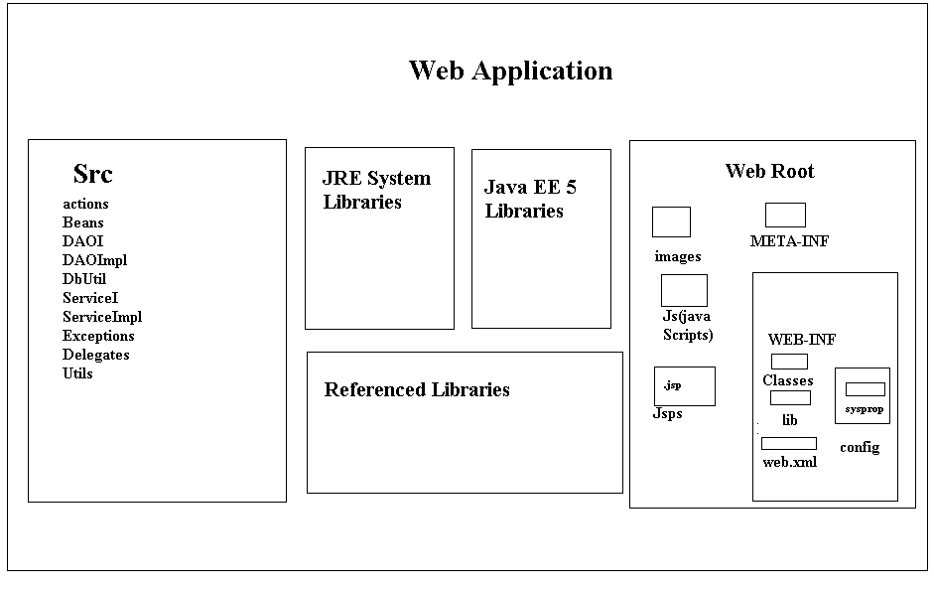

When we install tomcat server on server machine then tomcat server will provide a folder like tomcat 6.0 called as “Home-Directory”.
Home-Directory:
Tomcat home-directory includes the folders like
Bin
Lib
Conf
Logs
Work
Web-apps and -------etc
Where purpose of the web-apps folder is to accommodate all the user defined web applications
If we want to deploy any web application in server we have to prepare a folder with respect to our application under web-apps folder called as Application Folder (context root)
Where Application Folder includes
Themes -- > to store Cascading Style Sheets (CSS)
Images -- > to store .jpg, .gif
Literature -- > to store .doc files
Src -- > to store source files like .java and soon
Static resources -- > like .html
Dynamic resources -- > like .jsp
WEB-INF -- > to maintain a web application information
Where WEB-INF folder includes
web.xml files to provide meta data about application deployment.
Lib folder to store the application required .jar files
Classes folder to store .class files of servlets, filters, lateness
The above web application directory structure can be divided into the following two parts
Public Area or Client Area:
It is an area, come under outside of WEB-INF folder, and inside of Application Folder.
If we deploy any resource under public area then client able to access that resources by using their names directly.
Private Area or Server Area:
The area which come under inside WEB-INF folder is private area. If we deploy any resources under private area then client unable to access that resources with their names directly.
Example, In general we are able to deploy of servlets under classes folder i.e. private area, here if we want to access servlets then we must define on URL pattern in web.xml file through this URL pattern only client able to access the servlets.
- > Deployment Description:
Deployment description is a web.xml file, which will provide some description or meta data about the web application deployment.
In general web.xml file should include
Servlets Configuration
Filters Configuration
Listeniers Configuration
Welcome Files Definitions
Initialization Parameters
Context Parameters
Loader Startup Configuration
Session Constraints
Tag Library Definition and etc.
Web.xml file is deployment description which will includes the above specified configurations to execute the web application by the container
As part of the web applications web.xml file if optional, still if you want to provide deployment descriptor then whose name must be web.xml, it is not variable name
To define an URL pattern for a particular servlet and to provide mapping between servlets and URL patterns we should use the following XML Tags in web.xml file
<web-app>
<servlet>
<servlet-name>logical name </servlet>
<servlet-class>fully qualified name of servlet</servlet-class>
</serlvet>
<servlet-mapping>
<serlvet-name>logical name</servlet-name>
<url-pattern>/url pattern name</url-pattern>
</servlet-mapping>
---
----
</web-app>

To define URL pattern in web.xml file we should use the following three approaches.
Exact match method
Directory match method
Extension match method
Directory Match Method:
If we want to define URL Pattern in web.xml file with this approach then it must starts with ‘/’ and ends with “ * ”
Ex: <url-pattern>/abc/*<url-pattern>
If we define URL Pattern in web.xml file with this approach then to access the respective servlet we must specify an URL Pattern at client URL, it must match with the prefix of the URL Pattern defined in web.xml file and may end with any thing.
Ex: http://localhost:8086/app1/abc - - >valid
http://localhost:8086/app1/abc /xyz- - >valid
Note:
As part of the web apps when we have a requirement to send group of requests to a particular server side component then we must use directory match method URL Pattern definition.
As part of the web apps in general we will use filters to provide pre processing of the request processing like authentication checks, security, data encryption, data compression. In this context in web apps it is required to use a single filter for many more no of web resources.
In the above context when we send requests to the web resources automatically all the requests must be gone through the respective filter. To achieve this requirement we must use directory match method to define URL Pattern in the respective filter configuration.

Extension Match Method:
In extension match method if we want to define any URL Pattern in web.xml file then it must starts with * and it must ends with a particular extension.
Ex: <url –pattern> * .xyz</url-pattern>
If we define URL Pattern with this approach in web.xml file to any specific resource then to access that resource we must specify an URL Pattern at client address bar, It may start with anything but it must end with the specified extension in web.xml file.
Ex: http://localhost:8086/abc.xyz - ->valid
http;//localhost:8086/abc/xyz - ->invalid
http://localhost:8086/a.xyz - ->valid
http://localhost:8086/b.abc - ->invalid
Note;
As part of the web apps when we have a requirement to pass all the no of requests to a particular web resource, where to define an URL Pattern for the web resources we should use extension match method
In general in MVC based web apps we must send all the requests to the controller servlet, in this situation to trap all the no of requests t the controller servlet we must use extension match method to define URL Pattern for the controller
- >Step3: Design Web Resources:
As part of the web apps in general we are going to provide web app logic or business logic in the form of web resources like servlets, jsp’s…
To prepare servlets in web apps servlet API has provided following predefined library as part of the packages like javax.servlet and java
>Design web Resources:
As part of the web apps in general we are going to provide web app logic or business logic in the form of web resources like servlets, jsp’s,--
To prepare servlets in web apps servlet API has provided following predefined library as part of the packages like javax.servlet and javax.servlet.http
WHAT IS SERVLET? HOW MANY WAYS WE ARE ABLE TO PREPARE SERVLET:
Servlet is an object available at server machine, which was implemented either directly or indirectly servlet interface.
As per the predefined library provided by servlet API are three ways to prepare servlets Implementing Servlet Interface Extending Generic Servlet Abstract Class Extending HTTP Servlet
Javax
Servlet
HTTP Servlet (abstract class)

Servlet(interface)
implements
Generic Servlet (abstract class)
Extends HTTP

Implementing Servlet Interface:
In this approach to prepare servlet we must take an userdefined class, which must implement servlet interface.

public class MyServlet implements Servlet
{

}
Extending Generic Servlet Abstract Class:
To prepare servlets with this approach we must define a class which must be a subclass to generic servlet abstract class
public class MyServlet extends Generic Servlet {
}

Extending HTTP Servlet:
In this approach to design servlet we must take an user defined class, which must be extended from http servlet abstract class.
Public class MyServlet extends HTTP Servlet
{
}
>Start the Server and Access the Web Application:
After designing the web app at server side we have to start the server to execute web app
To start the server we should use the following approaches
Execute either tomcat6.0 exe file or startup. Batch file as per the availability, which could be available in bin folder of tomcat home directory
Execute system service tomcat Start - - >Run- - >services.msc
Select tomcat6 - - >select the icons start service, stop service….
Execute system program apache tomcat’s start tomcat
Start - - >All Programs - ->Apache Tomcat 6 - - >Monitor Tomcat/Start Tomcat
The following example demonstrates how to design a servlet by using servlet interface and how to access it from client
JSP:
Jsp is a server side technology which can be used to generate dynamic response from server machine.
The main intention of introducing jsp technology is to reduce java code as much as possible.
→In general in web app we are able to utilize JSp pages
To generate dynamic response to the clinets with very good look and feel.

If u made any modifications on existed JSp pages,then
It is not required to perform recompilation and reloading because JSP pages are autocompiled and autoloaded.

DEPLOYMENT:
In general in web applications it is possible to deploy jsp pages at any location of the web.
Application directory structure but it is suggestable to deploy the jsp pages under Application floder.
If we deploy the jsp pages under application floder then we are able to access that jsp pages from client with respect with it’s name directly.
If we deploy any jsp page under private area that is under web-inf folder (or)classes folder then we are able to acess respect to jsp page by defining on url-pattern in web.xml file.
To define url pattern and to provide mapping between url-pattern and the respect to jsp-page we should use the following tags in web.xml.

<web-app>
<servlet>
<servlet-name>logicalname</servlet-name>
<jsp-file>/context relation path& jsp page</jsp-file>
</servlet>
<servlet-mapping>
<servlet-name>logical servlet</servlet-mapping>
<url-pattern>/pattern name</url-pattren>
</servlet-name>
</web-app>

EX:

<web-app>
<servlet>
<servlet-name>f</servlet-name>
<jsp-file>/web-INF/classes/first.jsp</jsp-file>
</servlet>
<servlet-mapping>
<servlet-name>f</servlet-name>
<url-pattern>/first</url-pattren>
</servlet-mapping>
</web-app>

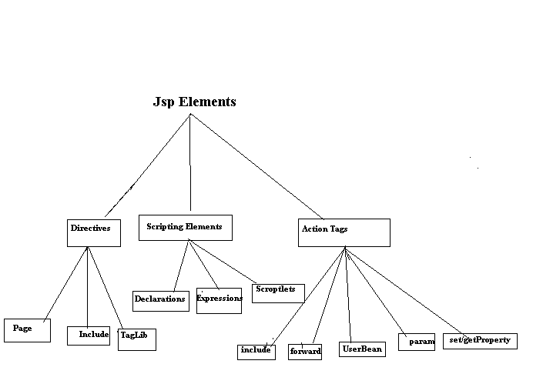
JSP ACTIONS:
→In jsp technology there are two types of actions .
1)standard Actions
2) custom Actions
1)standard Actions:

These are the actions which could be provided by the jsp technology along with the software.
→jsp technology has provided all the standard
Actions in the form of a set of predefined tags called as Action tags.
<jsp : useBean----->
<jsp: setProperty…..>
<jsp:getProperty……>
<jsp:include…>
<jsp:forward….>
<jsp:param…>
<jsp:plugin…>
<jsp:fallback..>
<jsp:params…>
<jsp:declarations…>
<jsp:scriptlet….>

Jsp:useBean Tag:
→the main purpose of this Tag is to interact with object from a jsp page to set and get object state.
→syntax:
<jsp:useBean id :”----“class:”……” scope:”…..”/>
→where id attribute can be used to specify a variable to hold the generated BEAN OBJECT REFERNCE.

Jsp:getProperty:
this tag can be used to getproperties of bean object.
<jsp:getProperty> contains the following 2 Attributes.
Name:
The name of the bean instance from which the required property is obtained.
It is equal to Id Attribute value of the <jsp:useBean>
Property:
The name of the java Bean property which has to retrieve.
<jsp:setProperty>
This Action can be used to set the properties of a bean object.
→We can use <jsp: setProperty> in the following way.
EX:
<jsp:setProperty name=”e” property=”ename” param=”ename”/>
1. Name →it refers name of the Bean object whose property has to set.
->this is exactly same as id Attribute of<jsp:useBean>
→it is mandatory.
2.property:
The name of the java Bean property which has to be set.
it is mandatory.
3. Value: it specifies the value which has to set to the javaBean property.
it is optional.
4. param:
This attribute specifies the name of request parameter whose value has to set to Bean property.
it is optional.
Database:
A database management system (DBMS) is computer software designed for the purpose of managing databases, a large set of structured data, and run operations on the data requested by numerous users. Typical examples of DBMSs include Oracle, DB2, Microsoft Access, Microsoft SQL Server, Firebird, PostgreSQL, MySQL, SQLite, FileMaker and Sybase Adaptive Server Enterprise. DBMSs are typically used by Database administrators in the creation of Database systems. Typical examples of DBMS use include accounting, human resources and customer support systems.

Originally found only in large companies with the computer hardware needed to support large data sets, DBMSs have more recently emerged as a fairly standard part of any company back office.

Description
A DBMS is a complex set of software programs that controls the organization, storage, management, and retrieval of data in a database. A DBMS includes:
- A modeling language to define the schema of each database hosted in the DBMS, according to the DBMS data model.
- The four most common types of organizations are the hierarchical, network, relational and object models. Inverted lists and other methods are also used. A given database management system may provide one or more of the four models. The optimal structure depends on the natural organization of the application's data, and on the application's requirements (which include transaction rate (speed), reliability, maintainability, scalability, and cost).
- The dominant model in use today is the ad hoc one embedded in SQL, despite the objections of purists who believe this model is a corruption of the relational model, since it violates several of its fundamental principles for the sake of practicality and performance. Many DBMSs also support the Open Database Connectivity API that supports a standard way for programmers to access the DBMS.
- Data structures (fields, records, files and objects) optimized to deal with very large amounts of data stored on a permanent data storage device (which implies relatively slow access compared to volatile main memory).

- A database query language and report writer to allow users to interactively interrogate the database, analyze its data and update it according to the users privileges on data.
- It also controls the security of the database.
- Data security prevents unauthorized users from viewing or updating the database. Using passwords, users are allowed access to the entire database or subsets of it called subschemas. For example, an employee database can contain all the data about an individual employee, but one group of users may be authorized to view only payroll data, while others are allowed access to only work history and medical data.
- If the DBMS provides a way to interactively enter and update the database, as well as interrogate it, this capability allows for managing personal databases. However, it may not leave an audit trail of actions or provide the kinds of controls necessary in a multi-user organization. These controls are only available when a set of application programs are customized for each data entry and updating function.

- A transaction mechanism, that ideally would guarantee the ACID properties, in order to ensure data integrity, despite concurrent user accesses (concurrency control), and faults (fault tolerance).
- It also maintains the integrity of the data in the database.
- The DBMS can maintain the integrity of the database by not allowing more than one user to update the same record at the same time. The DBMS can help prevent duplicate records via unique index constraints; for example, no two customers with the same customer numbers (key fields) can be entered into the database. See ACID properties for more information (Redundancy avoidance).

The DBMS accepts requests for data from the application program and instructs the operating system to transfer the appropriate data.
When a DBMS is used, information systems can be changed much more easily as the organization's information requirements change. New categories of data can be added to the database without disruption to the existing system.
Organizations may use one kind of DBMS for daily transaction processing and then move the detail onto another computer that uses another DBMS better suited for random inquiries and analysis. Overall systems design decisions are performed by data administrators and systems analysts. Detailed database design is performed by database administrators.
Database servers are specially designed computers that hold the actual databases and run only the DBMS and related software. Database servers are usually multiprocessor computers, with RAID disk arrays used for stable storage. Connected to one or more servers via a high-speed channel, hardware database accelerators are also used in large volume transaction processing environments.
DBMSs are found at the heart of most database applications. Sometimes DBMSs are built around a private multitasking kernel with built-in networking support although nowadays these functions are left to the operating system.
SQL
Structured Query Language (SQL) is the language used to manipulate relational databases. SQL is tied very closely with the relational model.

In the relational model, data is stored in structures called relations or tables.
SQL statements are issued for the purpose of:

Data definition: Defining tables and structures in the database (DDL used to create, alter and drop schema objects such as tables and indexes).

Data manipulation: Used to manipulate the data within those schema objects (DML Inserting, Updating, Deleting the data, and Querying the Database).

A schema is a collection of database objects that can include: tables, views, indexes and sequences

List of SQL statements that can be issued against an Oracle database schema are:

- ALTER - Change an existing table, view or index definition (DDL)
- AUDIT - Track the changes made to a table (DDL)
- COMMENT - Add a comment to a table or column in a table (DDL)
- COMMIT - Make all recent changes permanent (DML - transactional)
- CREATE - Create new database objects such as tables or views (DDL)
- DELETE - Delete rows from a database table (DML)
- DROP - Drop a database object such as a table, view or index (DDL)
- GRANT - Allow another user to access database objects such as tables or views (DDL)
- INSERT - Insert new data into a database table (DML)
- No AUDIT - Turn off the auditing function (DDL)
- REVOKE - Disallow a user access to database objects such as tables and views (DDL)
- ROLLBACK - Undo any recent changes to the database (DML - Transactional)
- SELECT - Retrieve data from a database table (DML)
- TRUNCATE - Delete all rows from a database table (can not be rolled back) (DML)
- UPDATE - Change the values of some data items in a database table (DML)

Normalization:
Normalization is the process of organizing data in a database. This includes creating tables and establishing relationships between those tables according to rules designed both to protect the data and to make the database more flexible by eliminating redundancy and inconsistent dependency.
Redundant data wastes disk space and creates maintenance problems. If data that exists in more than one place must be changed, the data must be changed in exactly the same way in all locations. A customer address change is much easier to implement if that data is stored only in the Customers table and nowhere else in the database.
What is an "inconsistent dependency"? While it is intuitive for a user to look in the Customers table for the address of a particular customer, it may not make sense to look there for the salary of the employee who calls on that customer. The employee's salary is related to, or dependent on, the employee and thus should be moved to the Employees table. Inconsistent dependencies can make data difficult to access because the path to find the data may be missing or broken.
There are a few rules for database normalization. Each rule is called a "normal form." If the first rule is observed, the database is said to be in "first normal form." If the first three rules are observed, the database is considered to be in "third normal form." Although other levels of normalization are possible, third normal form is considered the highest level necessary for most applications.
As with many formal rules and specifications, real world scenarios do not always allow for perfect compliance. In general, normalization requires additional tables and some customers find this cumbersome. If you decide to violate one of the first three rules of normalization, make sure that your application anticipates any problems that could occur, such as redundant data and inconsistent dependencies.
The following descriptions include examples.

First Normal Form :

Eliminate repeating groups in individual tables.
Create a separate table for each set of related data.
Identify each set of related data with a primary key.
Do not use multiple fields in a single table to store similar data. For example, to track an inventory item that may come from two possible sources, an inventory record may contain fields for Vendor Code 1 and Vendor Code 2.
What happens when you add a third vendor? Adding a field is not the answer; it requires program and table modifications and does not smoothly accommodate a dynamic number of vendors. Instead, place all vendor information in a separate table called Vendors, then link inventory to vendors with an item number key, or vendors to inventory with a vendor code key.

Second Normal Form :
Create separate tables for sets of values that apply to multiple records.
Relate these tables with a foreign key.
Records should not depend on anything other than a table's primary key (a compound key, if necessary). For example, consider a customer's address in an accounting system. The address is needed by the Customers table, but also by the Orders, Shipping, Invoices, Accounts Receivable, and Collections tables. Instead of storing the customer's address as a separate entry in each of these tables, store it in one place, either in the Customers table or in a separate Addresses table.

Third Normal Form :
Eliminate fields that do not depend on the key.
Values in a record that are not part of that record's key do not belong in the table. In general, any time the contents of a group of fields may apply to more than a single record in the table, consider placing those fields in a separate table.
For example, in an Employee Recruitment table, a candidate's university name and address may be included. But you need a complete list of universities for group mailings. If university information is stored in the Candidates table, there is no way to list universities with no current candidates. Create a separate Universities table and link it to the Candidates table with a university code key.
EXCEPTION: Adhering to the third normal form, while theoretically desirable, is not always practical. If you have a Customers table and you want to eliminate all possible interfield dependencies, you must create separate tables for cities, ZIP codes, sales representatives, customer classes, and any other factor that may be duplicated in multiple records. In theory, normalization is worth pursing. However, many small tables may degrade performance or exceed open file and memory capacities.
It may be more feasible to apply third normal form only to data that changes frequently. If some dependent fields remain, design your application to require the user to verify all related fields when any one is changed.

Other Normalization Forms :
Fourth normal form, also called Boyce Codd Normal Form (BCNF), and fifth normal form do exist, but are rarely considered in practical design. Disregarding these rules may result in less than perfect database design, but should not affect functionality. Eclipse IDE
Eclipse is an open-source software framework written primarily in Java. In its default form it is an Integrated Development Environment (IDE) for Java developers, consisting of the Java Development Tools (JDT) and the Eclipse Compiler for Java (ECJ). Users can extend its capabilities by installing plug-ins written for the Eclipse software framework, such as development toolkits for other programming languages, and can write and contribute their own plug-in modules. Language packs are available for over a dozen languages.

Architecture
The basis for Eclipse is the Rich Client Platform (RCP). The following components constitute the rich client platform:
- OSGi - a standard bundling framework
- Core platform - boot Eclipse, run plug-ins
- the Standard Widget Toolkit (SWT) - a portable widget toolkit
- JFace - viewer classes to bring model view controller programming to SWT, file buffers, text handling, text editors
- the Eclipse Workbench - views, editors, perspectives, wizards

Eclipse's widgets are implemented by a widget toolkit for Java called SWT, unlike most Java applications, which use the Java standard Abstract Window Toolkit (AWT) or Swing. Eclipse's user interface also leverages an intermediate GUI layer called JFace, which simplifies the construction of applications based on SWT.
Eclipse employs plug-ins in order to provide all of its functionality on top of (and including) the rich client platform, in contrast to some other applications where functionality is typically hard coded. This plug-in mechanism is a lightweight software componentry framework. In addition to allowing Eclipse to be extended using other programming languages such as C and Python, the plug-in framework allows Eclipse to work with typesetting languages like LaTeX, networking applications such as telnet, and database management systems. The plug-in architecture supports writing any desired extension to the environment, such as for configuration management. Java and CVS support is provided in the Eclipse SDK.
The key to the seamless integration of tools with Eclipse is the plugin. With the exception of a small run-time kernel, everything in Eclipse is a plug-in. This means that a plug-in you develop integrates with Eclipse in exactly the same way as other plug-ins; in this respect, all features are created equal.
The Eclipse SDK includes the Eclipse Java Development Tools, offering an IDE with a built-in incremental Java compiler and a full model of the Java source files. This allows for advanced refactoring techniques and code analysis. The IDE also makes use of a workspace, in this case a set of metadata over a flat filespace allowing external file modifications as long as the corresponding workspace "resource" is refreshed afterwards. The Visual Editor project allows interfaces to be created interactively, hence allowing Eclipse to be used as a RAD tool.

The following is a list of notable projects and plugins for the Eclipse IDE.
These projects are maintained by the Eclipse community and hosted by the Eclipse Foundation.

CODING

LoginForm.jsp

<!DOCTYPE HTML PUBLIC "-//w3c//dtd html 4.0 transitional//en">
<html>
<head>

<script language="JavaScript"
src="<%=request.getContextPath()
+ "/scripts/gen_validatorv31.js"%>"
type="text/javascript"></script>
<style type="text/css">
.Title {
font-family: Verdana;
font-weight: bold;
font-size: 8pt
}

.Title1 {
font-family: Verdana;
font-weight: bold;
font-size: 8pt
}
</style>

<script type="text/javascript">
function disableBackButton()
{
window.history.forward();
}
setTimeout("disableBackButton()", 0);
</script>

</head>

<body onload="javascript:disableBackButton()">

<body>
<jsp:include page="Header.jsp"></jsp:include>
<form action="<%=request.getContextPath() + "/LoginAction"%>"
method=post name="login">
<table bgcolor="#698B69" border="1" align="right" bgcolor="white"
width="40%" height='60%'>
<tr>
<td height="120" align="right"></td>
<td>
<table border="0" align="center"
style='position: absolute; top: 270pt; left: 470pt;'>
<tr align="center">
<strong><h3>
&nbsp&nbsp&nbspLogin Form
</h3> </strong>
</tr>
<tr>
<td align='right'>
<span class="Title">UserID :</span>
</td>
<td>
<input type="text" name="username">
</td>
</tr>
<tr>
<td align='right'>
<span class="Title">Password :</span>
</td>
<td>
<input type="password" name="password">
</td>
</tr>
<tr>
<td colspan="2">
<div align="center" class="style11">
<input type="submit" name="Submit" value="Sign In">
&nbsp;
<input name="Input2" type="reset" value="Clear">
</div>
</td>
</tr>

<tr>
<td>
&nbsp;
</td>
</tr>
<tr>
<td>
&nbsp;
</td>
<td>
<div align="center">
<a href="./Recoverpassword.jsp"><strong><font
color="#000000">Forgot Password</font> </strong> </a>
</div>
</td>
<td>
&nbsp;
</td>
</tr>
<tr>
<td>
&nbsp;
</td>
<td>
<div align="center">
<a href="./RegistrationForm.jsp"><strong><font
color="#000000">New Registration.....?</font> </strong> </a>
</div>
</td>
<td>
&nbsp;
</td>
</tr>

</table> </table>

</form>
<script language="JavaScript" type="text/javascript">
//You should create the validator only after the definition of the HTML form
var frmvalidator = new Validator("login");

frmvalidator.addValidation("username","req","Login Name is required");
frmvalidator.addValidation("username","alpha","Login Name is Only Characters");
frmvalidator.addValidation("password","req","Password is required");

</script>
<jsp:include page="Fotter.jsp"></jsp:include>
</body>
</html>

RegistrationForm.jsp

<!DOCTYPE HTML PUBLIC "-//W3C//DTD XHTML 1.0 Transitional//EN" "http://www.w3.org/TR/xhtml1/DTD/xhtml1-transitional.dtd">
<html xmlns="http://www.w3.org/1999/xhtml">
<%@ taglib prefix="c" uri="http://java.sun.com/jsp/jstl/core"%>
<head id="ctl00_header">
<head>

<script language="JavaScript" src="scripts/gen_validatorv31.js"
type="text/javascript"></script>
<script language="JavaScript" type="text/javascript"
src="scripts/ts_picker.js"></script>
<script language="JavaScript1.1" src="scripts/pass.js">
</script>
<script type="text/javascript" src="scripts/image.js"> </script>
<script type="text/javascript" src="scripts/general.js"> </script>
<script type="text/javascript" src="scripts/adi.js"> </script>
<script type="text/javascript" src="scripts/form_validation.js"> </script>

<script language="JavaScript" src="images/javascripts.js"></script>
<script language="JavaScript" src="images/pop-closeup.js"></script>
<script>

//var x_win = window.self;

function goOn() {
var port=document.register.port.value;
var host=document.register.host.value;
var userName=document.register.userName.value;
window.location.href='http://'+host+':'+port+'/IndianWildLife/CheckUserAction?userName='+userName+"&path=./RegistrationForm.jsp";

}
</script>

<style type="text/css">
.Title {
font-family: Verdana;
font-weight: bold;
font-size: 8pt
}

.Title1 {
font-family: Verdana;
font-weight: bold;
font-size: 8pt
}
</style></head>
<body>

<jsp:include page="Header.jsp"></jsp:include>
<br />
<center>
<h3>

<span class=subHead><br />Registration Form </span>
</h3>
</center>

<form action="./RegisterAction" name="register"
onsubmit="return validate()">
<!--<table border="1"><tr><td></td></tr></table>-->
<input type="hidden" name="port" value="<%=request.getLocalPort()%>" />
<input type="hidden" name="host" value="<%=request.getServerName()%>" />
<br />

<table border='0' align="center" width=70%>
<th colspan="6" bgcolor="#999933">
Account Details
</th>
<tr></tr>
<tr></tr>
<tr>
<td align='right'>
User Name :
</td>
<td width="303">
<input type="text" name="userName"
value="<% if(request.getParameter("userName")!=null)
out.print(request.getParameter("userName")); %>"
size="20" onblur="goOn()" />
&nbsp;&nbsp;&nbsp;&nbsp;&nbsp;&nbsp;&nbsp;&nbsp;&nbsp;&nbsp;&nbsp;

<font color="black"> ${requestScope.status } </font>

<td align='left'>

<b><font color="green"> <c:if
test="${'requestScope.status1'!='null'}">

<c:out value="${param.status1}"></c:out>
</c:if> </font>
</b>

</td>
<td></td><td></td>
<td></td>
</tr>
<tr>
<td align='right'>
PassWord :
</td>
<td>
<input type="password" name="password"
onkeyup="testPassword(document.forms.register.password.value);"
onchange="Encrypt(document.forms.register.password.value);" />
</td>
<td></td>
<td></td>
</tr>
<tr>
<td></td>
<td align='right'>
<a id="Words"> Strength :</a>
</td>
<td>
<center> <table border='0' cellpadding=0 cellspacing=0 colspan='2'>
<tr>
<td height=15 bgcolor=red></td>
</tr>
</table></center>
</td>

<td></td>
</tr>
<tr>
<td align='right'>
Confirm :
</td>
<td>
<input type="password" name="conformpassword" value="" size="20"
onBlur="checkconformpassword()" />
</td>
<td border="0" align="left" rowspan="5" colspan='2'>

<img alt="See Photo Here" id="previewField" src="images/flag.gif"
height="150" width="120" />

</td>
</tr>
<tr>
<td align='right'>
User Type :
</td>
<td width="276">
<select name="loginType" onChange="cleartext()">
<option value="select" selected="true">
<font size="3" face="Verdana">Select </font>
</option>

<option value="user">
<font size="3" face="Verdana">User</font>
</option>
<option value="V">
<font size="3" face="Verdana">Veterinarian</font>
</option>
<option value="C">
<font size="3" face="Verdana">Conservationist</font>
</option>
</select>
</td>
<tr>
<td align='right'>
SecurityQuestion :
</td>
<td>
<select name="squest">
<option value="select" selected="true">
<font size="3" face="Verdana">--Select One---</font>
</option>
<option value="What is your favorite pastime?">
<font size="3" face="Verdana">What is your favorite
pastime?</font>
</option>
<option value="Who your childhood hero?">
<font size="3" face="Verdana">Who your childhood hero?</font>
</option>
<option value="What is the name of your first school?">
<font size="3" face="Verdana">What is the name of your
first school?</font>
</option>
<option value="Where did you meet your spouse?">
<font size="3" face="Verdana">Where did you meet your
spouse?</font>
</option>
<option value="What is your favorite sports team?">
<font size="3" face="Verdana">What is your favorite
sports team?</font>
</option>
<option value="What is your father middle name?">
<font size="3" face="Verdana">What is your father middle
name?</font>
</option>
<option value="What was your high school mascot?">
<font size="3" face="Verdana">What was your high school
mascot?</font>
</option>
<option value="What make was your first car or bike?">
<font size="3" face="Verdana">What make was your first
car or bike?</font>
</option>
<option value="What is your pet name?">
<font size="3" face="Verdana">What is your pet name?</font>
</option>
</select>
</td>
</tr>
<tr>
<td colspan="2" align='center'>
<input type="checkbox" name="ch" value="1"
onClick="check(register)" />
Own Question :
</td>
</tr>
<tr>
<td>
<span class="style3"><font size="3" face="verdana"></font>
</td>
<td>
<input type="text" name="ownquest" disabled="disabled" size="37" />
</td>
</tr>
<tr>
<td align='right'>
Security Answer :
</td>
<td>
<input type="text" name="secrete" value="" size="20" />
</td>
</tr>

<tr></tr>
<tr></tr>
<th colspan="6" bgcolor="#999933">
Personal Details
</th>
<tr></tr>
<tr></tr>
<tr>
<td align='right'>
First Name :
</td>
<td width="276">
<input type="text" name="firstName" value="" />
</td>
<td align='right'>
Gender :
</td>
<td>
<select name="gender">
<option value="select" selected="true">
<font size="3" face="Verdana">--Select--</font>
</option>
<option value="Male">
<font size="3" face="Verdana">Male</font>
</option>
<option value="Female">
<font size="3" face="Verdana">Female</font>
</option>
</select>
</td>
</tr>
<tr>
<td align='right'>
Last Name :
</td>
<td width="276">
<input type="text" name="lastName" value="" size="20" />
</td>
<td align='right'>
Email :
</td>
<td>
<input type="text" name="email" value="" size="20" />
</td>
</tr>
<tr>
<td align='right'>
Birth Date :
</td>
<td>
<input type="text" name="birthdate" value="" size="20"
readonly="readonly" />
<a
href="javascript:show_calendar('document.register.birthdate', document.register.birthdate.value);">
<img src="images/cal.gif" alt="a" width="18" height="18"
border="0" /> </a>
</td>
<td align='right'>
Fax No :
</td>
<td>
<input type="text" name="fax" value="" size="20" />
</td>
</tr>
<tr>
<td align='right'>
Browse Photo :
</td>
<td>
<input type="file" name="photo" class="textfield"
onChange="preview(this)" />
</td>
<td></td>
<td></td>
</tr>
<tr>
<td></td>
<td></td>
<tr>
<td></td>
<td></td>
</tr>
<tr>
<td></td>
<td></td>
</tr>
<tr></tr>
<tr></tr>
<th colspan="6" bgcolor="#999933">
<center>
Contact Details
</center>
</th>
<tr></tr>
<tr></tr>
<tr>
<td align='right'>
Address Type :
</td>
<td width="276">
<select name="addressType" onChange="cleartext()">
<option value="select" selected="true">
<font size="3" face="Verdana">Select </font>
</option>
<option value="home">
<font size="3" face="Verdana">Home</font>
</option>
<option value="office">
<font size="3" face="Verdana">Office</font>
</option>
<option value="personal">
<font size="3" face="Verdana">Personal</font>
</option>
</select>
</td>
<td width="120" align='right'>
City :
</td>
<td width="273">
<input type="text" name="city" value="" size="20" />
</td>

</tr>
<tr>
<td align='right'>
House No :
</td>
<td>
<input type="text" name="houseNo" value="" size="20" />
</td>

<td width="120" align='right'>
District :
</td>
<td width="273">
<input type="text" name="district" value="" size="20" />
</td>
</tr>
<tr>
<td align='right'>
Street :
</td>
<td>
<input type="text" name="street" value="" size="20" />
</td>
<td align='right'>
State :
</td>
<td>
<input type="text" name="state" value="" size="20" />
</td>
</tr>
<tr>
<td align='right'>
Phone Type :
</td>
<td>
<select name="phoneType">
<option value="select" selected="true">
<font size="3" face="Verdana">Select</font>
</option>
<option value="home">
<font size="3" face="Verdana">Home</font>
</option>
<option value="office">
<font size="3" face="Verdana">Office</font>
</option>
<option value="mobile">
<font size="3" face="Verdana">Mobile</font>
</option>
</select>
</td>
<td align='right'>
Country :
</td>
<td>
<input type="text" name="country" value="" size="20" />
</td>
</tr>
<tr>
<td align='right'>
Phone No :
</td>
<td>
<input type="text" name="phoneNo" value="" size="20"
onBlur="ValidateForm()" />
</td>
<td align='right'>
Pin :
</td>
<td>
<input type="text" name="pin" value="" size="20"
onChange="showStatus()" />
</td>
</tr>
<th colspan="5">
&nbsp;
</th>
<tr></tr>
<tr></tr>

<tr>
<td></td>
<td align="right">
<font size="3" face="Verdana"> <input type="submit"
name="register" value="Register" />&nbsp; </font>
</td>
<td align="left">
<font size="3" face="Verdana"> <input type="reset"
name="cancel" value="Cancel" /> </font>
</td>
<td></td>
</tr>
</table>
<p>
<br />
<br />
<br />
</p>
<p>
&nbsp;
</p>
<p>
&nbsp;
</p>
<p>
&nbsp;
</p>
<p>
<br />
</p>

</form>

<script language="JavaScript" type="text/javascript">
//You should create the validator only after the definition of the HTML form
var frmvalidator = new Validator("register");

frmvalidator.addValidation("firstName","req","Please enter your First Name");
frmvalidator.addValidation("firstName","maxlen=20", "Max length for FirstName is 20");
frmvalidator.addValidation("firstName","alpha"," First Name Alphabetic chars only");

frmvalidator.addValidation("lastName","req","Please enter your Last Name");
frmvalidator.addValidation("lastName","maxlen=20","Max length is 20");
frmvalidator.addValidation("lastName","alpha"," Last Name Alphabetic chars only");

frmvalidator.addValidation("gender","dontselect=0");
frmvalidator.addValidation("birthdate","req","Please enter your birthdate");

frmvalidator.addValidation("photo","req","Please Load Your Photo");

frmvalidator.addValidation("email","maxlen=50");
frmvalidator.addValidation("email","req");
frmvalidator.addValidation("email","email");

frmvalidator.addValidation("addressType","dontselect=0");

frmvalidator.addValidation("houseNo","req","Please enter your House Number");

frmvalidator.addValidation("street","req","Please enter your Street Number");
frmvalidator.addValidation("phoneType","dontselect=0");
frmvalidator.addValidation("phoneNo","req");

frmvalidator.addValidation("phoneNo","maxlen=50");
frmvalidator.addValidation("phoneNo","numeric");
frmvalidator.addValidation("phoneNo","Phone");

frmvalidator.addValidation("city","req","Please enter your city Name");
frmvalidator.addValidation("state","req","Please enter your State Name");
frmvalidator.addValidation("country","req","Please enter your Country Name");
frmvalidator.addValidation("pin","req","Please enter your pin Number");

frmvalidator.addValidation("userName","req","Please enter your Username");
frmvalidator.addValidation("password","req","Please enter your Password");
frmvalidator.addValidation("conformpassword","req","Please enter your Confirm Password");
frmvalidator.addValidation("secrete","req","Please enter your Answer");
frmvalidator.addValidation("squest","dontselect=0");
frmvalidator.addValidation("fax","req","Please enter Fax Number");

</script>

<br />
<br />

<jsp:include page="Footer.jsp"></jsp:include>

</body>
</html>

LoginAction.jsp :

package com.ecable.action;

import java.io.IOException;
import java.io.PrintWriter;
import java.util.Iterator;
import java.util.Vector;

import javax.servlet.RequestDispatcher;
import javax.servlet.ServletException;
import javax.servlet.http.HttpServlet;
import javax.servlet.http.HttpServletRequest;
import javax.servlet.http.HttpServletResponse;
import javax.servlet.http.HttpSession;

import com.ecable.daoImpl.SecurityDAO;
import com.ecable.bean.ProfileTO;

public class LoginAction extends HttpServlet {

/**
* The doPost method of the servlet. <br>
*
* This method is called when a form has its tag value method equals to
* post.
*
* @param request
* the request send by the client to the server
* @param response
* the response send by the server to the client
* @throws ServletException
* if an error occurred
* @throws IOException
* if an error occurred
*/
public void doPost(HttpServletRequest request, HttpServletResponse response)
throws ServletException, IOException {

String target = "LoginForm.jsp?status=Invalid username and password";
try {
Vector<ProfileTO> vprof =new Vector<ProfileTO>();
HttpSession session = request.getSession();
ProfileTO rb = new ProfileTO();
String username = request.getParameter("username");
rb.setLoginID(username);
String pass = request.getParameter("password");
rb.setPassword(pass);
System.out.println(username);
System.out.println(pass);
vprof = new SecurityDAO().loginCheck(rb);
Iterator it = vprof.listIterator();
String role="";
String state="";
String district="";
String city="";
int userid=0;
if(it.hasNext()) {

rb = (ProfileTO) it.next();
userid=rb.getUserid();
role=rb.getLogintype();
state=rb.getState();
district=rb.getDistrict();
city=rb.getCity();}
System.out.println(userid);System.out.println(role);System.out.println(state);System.out.println(district);System.out.println(city);
if (role.equals("Admin")) {
target = "adminhome.jsp?status=Welcome " + username;
session.setAttribute("user", username);
session.setAttribute("role", role);
session.setAttribute("pass", pass);
session.setAttribute("userid", userid);
session.setAttribute("state", state);
session.setAttribute("district", district);
session.setAttribute("city", city);
} else if (role.equals("Operator")) {

target = "Operatorhome.jsp?status=Welcome " + username;
session.setAttribute("user", username);
session.setAttribute("role", role);
session.setAttribute("pass", pass);
session.setAttribute("userid", userid);
session.setAttribute("state", state);
session.setAttribute("district", district);
session.setAttribute("city", city);
} else if (role.equals("Customer")) {

target = "Customerhome.jsp?status=Welcome " + username;
session.setAttribute("user", username);
session.setAttribute("role", role);
session.setAttribute("pass", pass);
session.setAttribute("userid", userid);
session.setAttribute("state", state);
session.setAttribute("district", district);
session.setAttribute("city", city);
} else
target = "LoginForm.jsp?status=Invalid username and password";
} catch (Exception e) {
e.printStackTrace();
}
RequestDispatcher rd = request.getRequestDispatcher(target);
rd.forward(request, response);
}

}
Delegate.java
package com.ecable.delegate;

import java.util.Vector;

import com.ecable.exception.ConnectionException;
import com.ecable.exception.DataNotFoundException;
import com.ecable.exception.LoginException;
import com.ecable.bean.DistrictTO;
import com.ecable.serviceI.DistrictServiceI;
import com.ecable.serviceImpl.DistrictServiceImpl;

public class DistrictMgrDelegate {

DistrictServiceI dsi=new DistrictServiceImpl();

public boolean insertDistrict(DistrictTO dt) throws LoginException, ConnectionException{

return dsi.insertDistrict(dt);

}

public Vector<DistrictTO> viewDist() throws ConnectionException, DataNotFoundException{

return dsi.viewDist();

}

public DistrictTO viewDistAt( int did) throws ConnectionException, DataNotFoundException{

return dsi.viewDistAt(did);

}

public boolean deleteDist(int did) throws ConnectionException{

return dsi.deleteDist(did);

}
public boolean updateDist(DistrictTO dt) throws ConnectionException{

return dsi.updateDist(dt);
}

public Vector<DistrictTO> getDistName(String sname) throws ConnectionException, DataNotFoundException{

return dsi.getDistName(sname);
}
}

ServiceImpl.java
package com.ecable.serviceImpl;

import java.util.Vector;

import com.ecable.bean.DistrictTO;
import com.ecable.daoI.DistrictDaoI;
import com.ecable.daoImpl.DistrickDaoImpl;
import com.ecable.exception.ConnectionException;
import com.ecable.exception.DataNotFoundException;
import com.ecable.exception.LoginException;
import com.ecable.serviceI.DistrictServiceI;

public class DistrictServiceImpl implements DistrictServiceI{

DistrictDaoI daoi=new DistrickDaoImpl();

public boolean insertDistrict(DistrictTO dt)throws LoginException,ConnectionException{

return daoi.insertDistrict(dt);

}
public Vector<DistrictTO> viewDist()throws ConnectionException,DataNotFoundException{

return daoi.viewDist();
}
public DistrictTO viewDistAt( int did)throws ConnectionException,DataNotFoundException{

return daoi.viewDistAt(did);

}
public boolean deleteDist(int did)throws ConnectionException{

return daoi.deleteDist(did);
}
public boolean updateDist(DistrictTO dt)throws ConnectionException{

return daoi.updateDist(dt);
}
public Vector<DistrictTO> getDistName(String sname)throws ConnectionException,DataNotFoundException{

return daoi.getDistName(sname);

}

}
DaoInterface.java

package com.ecable.daoI;

import java.util.Vector;

import com.ecable.bean.DistrictTO;

public interface DistrictDaoI {

public boolean insertDistrict(DistrictTO dt);
public Vector<DistrictTO> viewDist();
public DistrictTO viewDistAt( int did);
public boolean deleteDist(int did);
public boolean updateDist(DistrictTO dt);
public Vector<DistrictTO> getDistName(String sname);

}

DaoImpl.java

package com.ecable.daoImpl;

import java.sql.Connection;
import java.sql.PreparedStatement;
import java.sql.ResultSet;
import java.sql.SQLException;
import java.sql.Statement;
import java.util.Vector;

import com.ecable.bean.DistrictTO;
import com.ecable.daoI.DistrictDaoI;
import com.ecable.dao.AbstractDataAccessObject;

public class DistrickDaoImpl implements DistrictDaoI {

Connection con;
PreparedStatement pstmt;
Statement stmt;
ResultSet rs;
ResultSet rs1;

public DistrickDaoImpl(){

con=new AbstractDataAccessObject().getConnection();

}

public boolean insertDistrict(DistrictTO dt)
{
boolean flag=true;
try{

pstmt=con.prepareStatement("insert into district values((select nvl(max(did),100)+1 from district),?,?)");

int sid=dt.getStateid();

System.out.println("in DAo stateid is.........."+sid);
String dname=dt.getDname();
System.out.println("in dao Dname is.........."+dname);

pstmt.setInt(1, sid);
pstmt.setString(2, dname);

int insert=pstmt.executeUpdate();

if(insert>0)
{

con.commit();
}
else
{
flag=false;
con.rollback();
}

}

catch (Exception e)
{
e.printStackTrace();
flag=false;
try
{
con.rollback();
}
catch (SQLException se)
{
se.printStackTrace();
}
}

finally
{
try{
if(con!=null)
con.close();
}
catch(Exception e){}
}
return flag;
}

public Vector<DistrictTO> viewDist()
{

Vector<DistrictTO> vsb=null;
String sname="";

try{

con=new AbstractDataAccessObject().getConnection();
pstmt=con.prepareStatement("select *from district");

rs=pstmt.executeQuery();

vsb=new Vector<DistrictTO>();

while(rs.next())
{

int did=rs.getInt(1);
int sid=rs.getInt(2);
String dname=rs.getString(3);

DistrictTO sf=new DistrictTO();

stmt=con.createStatement();
rs1=stmt.executeQuery("select statename from state where stateid="+sid);
if(rs1.next())
{
sname=rs1.getString(1);

}
sf.setDid(did);
sf.setDname(dname);
sf.setStateid(sid);
sf.setSname(sname);
vsb.add(sf);

}

}
catch (Exception e) {
e.printStackTrace();
}
return vsb;
}

public DistrictTO viewDistAt( int did1)
{

DistrictTO sf=null;
String sname="";

try{

pstmt=con.prepareStatement("select * from district where did=?");
pstmt.setInt(1, did1);
rs=pstmt.executeQuery();

while(rs.next())
{
int did=rs.getInt(1);
int sid=rs.getInt(2);
String dname=rs.getString(3);

sf=new DistrictTO();
stmt=con.createStatement();
rs1=stmt.executeQuery("select statename from state where stateid="+sid);
if(rs1.next())

sname=rs1.getString(1);

sf.setDid(did);
sf.setDname(dname);
sf.setStateid(sid);
sf.setSname(sname);

}

}
catch (Exception e) {
e.printStackTrace();
}
return sf;
}

public boolean deleteDist(int did)
{
boolean flag=true;
try{

pstmt=con.prepareStatement("delete from district where did=?");

pstmt.setInt(1, did);

int delete=pstmt.executeUpdate();

if(delete>0)
{

con.commit();
}
else
{
flag=false;
con.rollback();
}

}

catch (Exception e)
{
e.printStackTrace();
flag=false;
try
{
con.rollback();
}
catch (SQLException se)
{
se.printStackTrace();
}
}

finally
{
try{
if(con!=null)
con.close();
}
catch(Exception e){}
}
return flag;
}

public boolean updateDist(DistrictTO sf)
{
boolean flag=true;
try{

pstmt=con.prepareStatement("update district set dname=? where did=? ");

int did=sf.getDid();

System.out.println("in DAo District id is.........."+did);

String dname=sf.getDname();

pstmt.setString(1, dname);
pstmt.setInt(2, did);

int update=pstmt.executeUpdate();

if(update>0)
{

con.commit();
}
else
{
flag=false;
con.rollback();
}

}

catch (Exception e)
{
e.printStackTrace();
flag=false;
try
{
con.rollback();
}
catch (SQLException se)
{
se.printStackTrace();
}
}

finally
{
try{
if(con!=null)
con.close();
}
catch(Exception e){}
}
return flag;
}

public Vector<DistrictTO> getDistName(String sname)
{
Vector<DistrictTO> vsb=null;

try{

pstmt=con.prepareStatement("select dname,did from district where stateid in(select stateid from state where statename=?)");

pstmt.setString(1, sname);
System.out.println(sname);

rs=pstmt.executeQuery();
vsb=new Vector<DistrictTO>();

while(rs.next())
{

String dname=rs.getString(1);
int did=rs.getInt(2);

DistrictTO sf=new DistrictTO();

sf.setDname(dname);
sf.setDid(did);

vsb.add(sf);
}

}
catch (Exception e) {
e.printStackTrace();
}
return vsb;

}

}

AbstractDataAccessObject.java
package com.ecable.dao;

import java.sql.Connection;
import java.sql.DriverManager;
import java.sql.ResultSet;
import java.sql.SQLException;
import java.sql.Statement;
import java.util.Properties;

import javax.naming.InitialContext;
import javax.naming.NamingException;
import javax.sql.DataSource;

import com.ecable.util.LoggerManager;

public class AbstractDataAccessObject
{
private Connection mCon;
private static Properties mProps;

/**
* @return the props
*/
public Properties getProperties()
{
return mProps;
}

/**
* @param props
* application properties object
*/
public void setProperties(Properties aProps)
{
mProps = aProps;
}

public Connection getConnection()
{
try
{
Properties aProps = getProperties();
Class.forName(aProps.getProperty("driver"));
mCon = DriverManager.getConnection(aProps.getProperty("url"), aProps.getProperty("duser"), aProps.getProperty("dpass"));
}
catch (ClassNotFoundException cnfe)
{
LoggerManager.writeLogWarning(cnfe);
}
catch (SQLException se)
{
LoggerManager.writeLogWarning(se);
}
return mCon;
}

/* public ConnectionTO getConnection(String cp)
{
try
{
Properties aProps = getProperties();
Class.forName( aProps.getProperty("driver") );

String JNDI = aProps.getProperty("JNDI_NAME");

try
{
InitialContext ictx = new InitialContext();
DataSource ds = (DataSource) ictx.lookup(JNDI);
mCon = ds.getConnection();
}
catch (NamingException ne)
{
LoggerManager.writeLogWarning(ne);
}
}
catch (ClassNotFoundException cnfe)
{
LoggerManager.writeLogWarning(cnfe);
}
catch (SQLException se)
{
LoggerManager.writeLogWarning(se);
}
return mCon;
}*/

public int getSequenceID(String tableName, String pkid)
{
int id = 0;
try
{
mCon = getConnection();
Statement st = mCon.createStatement();
ResultSet rs = st.executeQuery("select max("+pkid+") from "+tableName);
if(rs.next())
id=rs.getInt(1);
id++;
}
catch(SQLException se)
{
LoggerManager.writeLogWarning(se);
}
catch(Exception e)
{
LoggerManager.writeLogWarning(e);
}
finally
{
try
{
mCon.close();
}
catch(SQLException se)
{
LoggerManager.writeLogWarning(se);
}
catch(Exception e)
{
LoggerManager.writeLogWarning(e);
}
}
return id;
}
}

TESTING

Software Testing is the process used to help identify the correctness, completeness, security, and quality of developed computer software. Testing is a process of technical investigation, performed on behalf of stakeholders, that is intended to reveal quality-related information about the product with respect to the context in which it is intended to operate. This includes, but is not limited to, the process of executing a program or application with the intent of finding errors. Quality is not an absolute; it is value to some person. With that in mind, testing can never completely establish the correctness of arbitrary computer software; testing furnishes a criticism or comparison that compares the state and behavior of the product against a specification. An important point is that software testing should be distinguished from the separate discipline of Software Quality Assurance (SQA), which encompasses all business process areas, not just testing.
There are many approaches to software testing, but effective testing of complex products is essentially a process of investigation, not merely a matter of creating and following routine procedure. One definition of testing is "the process of questioning a product in order to evaluate it", where the "questions" are operations the tester attempts to execute with the product, and the product answers with its behavior in reaction to the probing of the tester[citation needed]. Although most of the intellectual processes of testing are nearly identical to that of review or inspection, the word testing is connoted to mean the dynamic analysis of the product—putting the product through its paces. Some of the common quality attributes include capability, reliability, efficiency, portability, maintainability, compatibility and usability. A good test is sometimes described as one which reveals an error; however, more recent thinking suggests that a good test is one which reveals information of interest to someone who matters within the project community.

Introduction:
In general, software engineers distinguish software faults from software failures. In case of a failure, the software does not do what the user expects. A fault is a programming error that may or may not actually manifest as a failure. A fault can also be described as an error in the correctness of the semantic of a computer program. A fault will become a failure if the exact computation conditions are met, one of them being that the faulty portion of computer software executes on the CPU. A fault can also turn into a failure when the software is ported to a different hardware platform or a different compiler, or when the software gets extended. Software testing is the technical investigation of the product under test to provide stakeholders with quality related information.

Software testing may be viewed as a sub-field of Software Quality Assurance but typically exists independently (and there may be no SQA areas in some companies). In SQA, software process specialists and auditors take a broader view on software and its development. They examine and change the software engineering process itself to reduce the amount of faults that end up in the code or deliver faster.
Regardless of the methods used or level of formality involved the desired result of testing is a level of confidence in the software so that the organization is confident that the software has an acceptable defect rate. What constitutes an acceptable defect rate depends on the nature of the software. An arcade video game designed to simulate flying an airplane would presumably have a much higher tolerance for defects than software used to control an actual airliner.
A problem with software testing is that the number of defects in a software product can be very large, and the number of configurations of the product larger still. Bugs that occur infrequently are difficult to find in testing. A rule of thumb is that a system that is expected to function without faults for a certain length of time must have already been tested for at least that length of time. This has severe consequences for projects to write long-lived reliable software.
A common practice of software testing is that it is performed by an independent group of testers after the functionality is developed but before it is shipped to the customer. This practice often results in the testing phase being used as project buffer to compensate for project delays. Another practice is to start software testing at the same moment the project starts and it is a continuous process until the project finishes.
Another common practice is for test suites to be developed during technical support escalation procedures. Such tests are then maintained in regression testing suites to ensure that future updates to the software don't repeat any of the known mistakes.
It is commonly believed that the earlier a defect is found the cheaper it is to fix it.
Unit tests are maintained along with the rest of the software source code and generally integrated into the build process (with inherently interactive tests being relegated to a partially manual build acceptance process).
The software, tools, samples of data input and output, and configurations are all referred to collectively as a test harness.
History
The separation of debugging from testing was initially introduced by Glen ford J. Myers in his 1978 book the "Art of Software Testing". Although his attention was on breakage testing it illustrated the desire of the software engineering community to separate fundamental development activities, such as debugging, from that of verification. Drs. Dave Gelperin and William C. Hetzel classified in 1988 the phases and goals in software testing as follows: until 1956 it was the debugging oriented period, where testing was often associated to debugging: there was no clear difference between testing and debugging. From 1957-1978 there was the demonstration oriented period where debugging and testing was distinguished now - in this period it was shown, that software satisfies the requirements. The time between 1979-1982 is announced as the destruction oriented period, where the goal was to find errors. 1983-1987 is classified as the evaluation oriented period: intention here is that during the software lifecycle a product evaluation is provided and measuring quality. From 1988 on it was seen as prevention oriented period where tests were to demonstrate that software satisfies its specification, to detect faults and to prevent faults. Dr. Gelperin chaired the IEEE 829-1988 (Test Documentation Standard) with Dr. Hetzel writing the book "The Complete Guide of Software Testing". Both works were pivotal in to today's testing culture and remain a consistent source of reference. Dr. Gelperin and Jerry E. Durant also went on to develop High Impact Inspection Technology that builds upon traditional Inspections but utilizes a test driven additive.

Testing Concepts

- Testing

- Testing Methodologies

- Black box Testing:
- White box Testing.
- Gray Box Testing.

- Levels of Testing

  - Unit Testing.
  - Module Testing.
  - Integration Testing.
  - System Testing.
  - User Acceptance Testing.

- Types Of Testing

  - Smoke Testing.
  - Sanitary Testing.
  - Regression Testing.
  - Re-Testing.
  - Static Testing.
  - Dynamic Testing.
  - Alpha-Testing.
  - Beta-Testing.
  - Monkey Testing.
  - Compatibility Testing.
  - Installation Testing.
  - Adhoc Testing.
  - Ext….

TCD (Test Case Documentation)

- STLC
  - Test Planning.
  - Test Development.
  - Test Execution.
  - Result Analysis.
  - Bug-Tracing.
  - Reporting.

- Microsoft Windows – Standards
- Manual Testing
- Automation Testing (Tools)
  - Win Runner.
  - Test Director.

Testing:

- The process of executing a system with the intent of finding an error.
- Testing is defined as the process in which defects are identified, isolated, subjected for rectification and ensured that product is defect free in order to produce the quality product and hence customer satisfaction.
- Quality is defined as justification of the requirements
- Defect is nothing but deviation from the requirements
- Defect is nothing but bug.
- Testing --- The presence of bugs
- Testing can demonstrate the presence of bugs, but not their absence
- Debugging and Testing are not the same thing!
- Testing is a systematic attempt to break a program or the AUT
- Debugging is the art or method of uncovering why the script /program did not execute properly.
Testing Methodologies:

- Black box Testing: is the testing process in which tester can perform testing on an application without having any internal structural knowledge of application.
Usually Test Engineers are involved in the black box testing.
- White box Testing: is the testing process in which tester can perform testing on an application with having internal structural knowledge.
Usually The Developers are involved in white box testing.

- Gray Box Testing: is the process in which the combination of black box and white box tonics’ are used.

Levels of Testing:

Module1 Module2 Module3
Units |  | Units |  | Units
i/p Integration o/p i/p Integration o/p

System Testing: Presentation + business +Databases
⓪UAT: user acceptance testing

STLC (SOFTWARE TESTING LIFE CYCLE)

Test Planning:
1.Test Plan is defined as a strategic document which describes the procedure how to perform various testing on the total application in the most efficient way.
2.This document involves the scope of testing,
3. Objective of testing,
4. Areas that need to be tested,
5. Areas that should not be tested,
6. Scheduling Resource Planning,
7. Areas to be automated, various testing tools
Used….
Test Development:
1. Test case Development (check list)
2. Test Procedure preparation. (Description of the Test cases).
1. Implementation of test cases. Observing the result.

Result Analysis: 1. Expected value: is nothing but expected behavior
Of application.
2. Actual value: is nothing but actual behavior of
application
Bug Tracing: Collect all the failed cases, prepare documents.

Reporting: Prepare document (status of the application)

Types Of Testing:

①> Smoke Testing: is the process of initial testing in which tester looks for the availability of all the functionality of the application in order to perform detailed testing on them. (Main check is for available forms)

①> Sanity Testing: is a type of testing that is conducted on an application initially to check for the proper behavior of an application that is to check all the functionality are available before the detailed testing is conducted by on them.

①> Regression Testing: is one of the best and important testing. Regression testing is the process in which the functionality, which is already tested before, is once again tested whenever some new change is added in order to check whether the existing functionality remains same.

①>Re-Testing: is the process in which testing is performed on some functionality which is already tested before to make sure that the defects are reproducible and to rule out the environments issues if at all any defects are there.

①Static Testing: is the testing, which is performed on an application when it is not been executed.ex: GUI, Document Testing

①Dynamic Testing: is the testing which is performed on an application when it is being executed.ex: Functional testing.

①Alpha Testing: it is a type of user acceptance testing, which is conducted on an application when it is just before released to the customer.

① Beta-Testing: it is a type of UAT that is conducted on an application when it is released to the customer, when deployed in to the real time environment and being accessed by the real time users.

① Monkey Testing: is the process in which abnormal operations, beyond capacity operations are done on the application to check the stability of it in spite of the users abnormal behavior.

①Compatibility testing: it is the testing process in which usually the products are tested on the environments with different combinations of databases (application servers, browsers…etc) In order to check how far the product is compatible with all these environments platform combination.

Installation Testing: it is the process of testing in which the tester try to install or try to deploy the module into the corresponding environment by following the guidelines produced in the deployment document and check whether the installation is successful or not.

Adhoc Testing: Adhoc Testing is the process of testing in which unlike the formal testing where in test case document is used, with out that test case document testing can be done of an application, to cover that testing of the future which are not covered in that test case document. Also it is intended to perform GUI testing which may involve the cosmotic issues.

TCD (Test Case Document:

Test Case Document Contains

- Test Scope (or) Test objective
- Test Scenario
- Test Procedure
- Test case
This is the sample test case document for the Acadamic details of student project:

Test scope:

- Test coverage is provided for the screen “ Acadamic status entry” form of a student module of university management system application
- Areas of the application to be tested

Test Scenario:

- When the office personals use this screen for the marks entry, calculate the status details, saving the information on student’s basis and quit the form.

Test Procedure:

- The procedure for testing this screen is planned in such a way that the data entry, status calculation functionality, saving and quitting operations are tested in terms of Gui testing, Positive testing, Negative testing using the corresponding Gui test cases, Positive test cases, Negative test cases respectively

Test Cases:

- Template for Test Case

T.C.No | Description | Exp | Act | Result
1  2 | Enter user name and password  Enter valid date to store in the database | True/false  Accurate/Valid  data | True  Valid date | Home page  Data stored  successfully

Guidelines for Test Cases:

- GUI Test Cases:

- Total no of features that need to be check
- Look & Feel
- Look for Default values if at all any (date & Time, if at all any require)
- Look for spell check

Example for Gui Test cases:

T.C.No | Description | Expected value | Actual value | Result
1 | Check for all the features in the screen | The screen must contain all the features
2 | Check for the alignment of the objects as per the validations | The alignment should be in proper way

- Positive Test Cases:

- The positive flow of the functionality must be considered
- Valid inputs must be used for testing
- Must have the positive perception to verify whether the requirements are justified.

Example for Positive Test cases:

T.C.No | Description | Expected value | Actual value | Result
1 | Check for the date Time Auto Display | The date and time of the system must be displayed
2 | Enter the valid Roll no into the student roll no field | It should accept

- Negative Test Cases:

- Must have negative perception.
- Invalid inputs must be used for test.

Example for Negative Test cases:
T.C.No | Description | Expected value | Actual value | Result
1 | Try to modify The information in date and time | Modification should not be allow
2 | Enter invalid data in to the student details form, click on save | It should not accept invalid data, save should not allow

Login Page Test Case
Test Case Name | Test Case Description | Test Steps
Test Case Name | Test Case Description | Step | Expected | Actual
Login | Validate Login | To verify that Login name on login page must be greater than 1 characters | enter login name less than 1 chars (say a) and password and click Submit button | an error message “Login not less than 1 characters” must be displayed
Login | Validate Login |  | enter login name 1 chars (say a) and password and click Submit button | Login success full or an error message “Invalid Login or Password” must be displayed
Pwd | Validate Password | To verify that Password on login page must be greater than 1 characters | enter Password less than 1 chars (say nothing) and Login Name and click Submit button | an error message “Password not less than 1 characters” must be displayed
Pwd02 | Validate Password | To verify that Password on login page must be allow special characters | enter Password with special characters(say !@hi&*P) Login Name and click Submit button | Login success full or an error message “Invalid Login or Password” must be displayed
Llnk | Verify Hyperlinks | To Verify the Hyper Links available at left side on login page working or not | Click Sign Up Link | Home Page must be displayed
Llnk | Verify Hyperlinks |  | Click Sign Up Link | Sign Up page must be displayed
Llnk | Verify Hyperlinks |  | Click New Users Link | New Users Registration Form must be displayed

Registration Page Test Case

Test Case Name | Test Case Description | Test Steps
Test Case Name | Test Case Description | Step | Expected | Actual
Registration | Validate User Name | To verify that User name on Registration page must be Declared | enter User name click Submit button | an error message User Name Must be Declared
Registration | Validate Password | To verify that Password on Registration page must be Declared | enter Password click Submit button | an error message Password Must be Declared
Registration | Validate First Name | To verify that First Name on Registration page must be Declared | enter First Name click Submit button | an error message First Name Must be Declared
Registration | Validate Last Name | To verify that Last Name on Registration page must be Declared | enter Last Name click Submit button | an error message Last Name Must be Declared
Registration | Validate Address | To verify that Address on Registration page must be Declared | enter Address click Submit button | an error message Address Must be Declared
Registration | Validate Phone number | To verify that Phone number on Registration page must be Declared | enter Phone number click Submit button | an error message Phone number Must be Declared
Registration | Validate Phone number is giving characters | To verify that Phone number (say abc) Registration page must be Declared | enter Phone number is only numeric values click Submit button | an error message Phone number Must be numeric Declared
Registration | Validate Phone number valid number | To verify that Phone number (say 1234) Registration page must be Declared | enter Phone number is Valid values click Submit button | an error message Phone number Must be Valid value Declared

LIMITATIONS AND SCOPE FOR FUTURE ENHANCEMENTS:
Limitations of the system:.
  - System works in all platforms and its compatible environments.
  - Advanced techniques are not used to check the authorization.

Future Enhancements:
It is not possible to develop a system that makes all the requirements of the user. User requirements keep changing as the system is being used. Some of the future enhancements that can be done to this system are:
- As the technology emerges, it is possible to upgrade the system and can be adaptable to desired environment.
- Because it is based on object-oriented design, any further changes can be easily adaptable.
- Based on the future security issues, security can be improved using emerging technologies.

PROJECT SUMMARY
This application software has been computed successfully and was also tested successfully by taking “test cases”. It is user friendly, and has required options, which can be utilized by the user to perform the desired operations.
The software is developed using Java as front end and Oracle as back end in Windows environment. The goals that are achieved by the software are:
- Optimum utilization of resources.
- Efficient management of records.
- Simplification of the operations.
- Less processing time and getting required information.
- User friendly.
- Portable and flexible for further enhancement.

CONCLUSION

WORK DONE:

The Optimized DWT-based Image Watermarking for Webwas successfully designed and is tested for accuracy and quality.
During this project we have accomplished all the objectives and this project meets the needs of the organization. The developed will be used in searching, retrieving and generating information for the concerned requests.
GOALS
  - Reduced entry work
  - Easy retrieval of information
  - Reduced errors due to human intervention
  - User friendly screens to enter the data
  - Portable and flexible for further enhancement
  - Web enabled.
  - Fast finding of information requested

BIBILIOGRAPHY

(1) Java Complete Reference by Herbert Shield
(2) Database Programming with JDBC and Java by George Reese
(3) Java and XML By Brett McLaughlin

(4) Wikipedia, URL: http://www.wikipedia.org.

(5) Answers.com, Online Dictionary, Encyclopedia and much more, URL: http://www.answers.com
(6) Google, URL: http://www.google.co.in
(7)Project Management URL: http://www.startwright.com/project.htm

